Chapter 2
Thinking Like an Economist
MULTIPLE CHOICE
1. Which is the best statement about the way economists study the economy?
a. They study the past, but do not try to predict the future.
b. They use a probabilistic approach based on correlations between economic events.
c. They devise theories, collect data, then analyze the data to test the theories.
d. They use controlled experiments much the same way a biologist or physicist does.
ANSWER: c. They devise theories, collect data, then analyze the data to test the theories.
TYPE: M SECTION: 1 DIFFICULTY: 2
2. Terms used by an economist would include
a. vector spaces and axioms.
b. torts and venues.
c. ego and cognitive dissonance.
d. comparative advantage and elasticity.
ANSWER: d. comparative advantage and elasticity.
TYPE: M SECTION: 1 DIFFICULTY: 2
3. By scientific method we mean
a. the use of modern electronic testing equipment to understand the world.
b. the dispassionate development and testing of theories about how the world works.
c. the use of controlled experiments in understanding the way the world works.
d. finding evidence to support preconceived theories about how the world works.
ANSWER: b. the dispassionate development and testing of theories about how the world works.
TYPE: M SECTION: 1 DIFFICULTY: 2
4. Who said, “The whole of science is nothing more than the refinement of everyday thinking.”?
a. Isaac Newton
b. Albert Einstein
c. Sigmund Freud
d. Benjamin Franklin
ANSWER: b. Albert Einstein
TYPE: M SECTION: 1 DIFFICULTY: 1
5. Albert Einstein once made the following observation about science:
a. “The whole of science is nothing more than the refinement of everyday thinking.”
b. “The whole of science is nothing more than an interesting intellectual exercise.”
c. “In order to understand science, one must rely solely on abstraction.”
d. “In order to understand science, one must transcend everyday thinking.”
ANSWER: a. “The whole of science is nothing more than the refinement of everyday thinking.”
TYPE: M SECTION: 1 DIFFICULTY: 2
6. Sir Isaac Newton’s development of the theory of gravity after observing an apple fall from a tree is an example of
a. controlled experiments used to develop scientific theories.
b. being in the right place at the right time.
c. an idea whose time had come.
d. the interplay between observation and theory in science.
ANSWER: d. the interplay between observation and theory in science.
TYPE: M SECTION: 1 DIFFICULTY: 2
7. A common thread between economics and other sciences such as physics is that
a. experiments are most often conducted in a lab.
b. real-world observations often lead to theories.
c. a Ph.D. is required to truly understand any science.
d. both deal primarily with abstract concepts.
ANSWER: b. real-world observations often lead to theories.
TYPE: M SECTION: 1 DIFFICULTY: 2
8. The use of theory and observation is more difficult in economics than in sciences such as physics due to the difficulty in
a. evaluating an economic experiment.
b. devising an economic experiment.
c. actually performing an experiment in an economic system.
d. All of the above are correct.
ANSWER: c. actually performing an experiment in an economic system.
TYPE: M SECTION: 1 DIFFICULTY: 2
9. Because it is difficult for economists to use experiments to generate data, they generally must
a. do without data.
b. use whatever data the world gives them.
c. select a committee of economists to make up data for all economists to use.
d. use hypothetical, computer-generated data.
ANSWER: b. use whatever data the world gives them.
TYPE: M SECTION: 1 DIFFICULTY: 2
10. When testing theories, economists
a. must make do with whatever data the world gives them.
b. can manipulate economic conditions easier than other scientific fields.
c. can enlist the government’s help to manipulate economic conditions.
d. can achieve statistically valid results with much smaller sample sizes.
ANSWER: a. must make do with whatever data the world gives them.
TYPE: M SECTION: 1 DIFFICULTY: 2
11. One difficulty economists face that some other scientists do not is that
a. unlike other sciences, economic studies must include the largest economic player, the government.
b. economists unfortunately receive less government funding than other scientists.
c. corporations are reluctant to disclose necessary information for economic research.
d. experiments are often difficult in economics.
ANSWER: d. experiments are often difficult in economics.
TYPE: M SECTION: 1 DIFFICULTY: 2
12. The most common data for testing economic theories come from
a. carefully controlled and conducted laboratory experiments.
b. traditional economies.
c. historical episodes of economic change.
d. centrally planned economies.
ANSWER: c. historical episodes of economic change.
TYPE: M SECTION: 1 DIFFICULTY: 2
13. For economists, substitutes for laboratory experiments are often
a. natural experiments offered by history.
b. computer-generated experiments.
c. studies conducted by other disciplines such as sociologists.
d. well-constructed simulations.
ANSWER: a. natural experiments offered by history.
TYPE: M SECTION: 1 DIFFICULTY: 2
14. Economists make assumptions
a. to diminish the chance of wrong answers.
b. to make the world easier to understand.
c. because all scientists make assumptions.
d. to make certain that all necessary variables are included.
ANSWER: b. to make the world easier to understand.
TYPE: M SECTION: 1 DIFFICULTY: 2
15. The art of scientific thinking includes
a. knowing how the major organs of the human body work.
b. understanding every scientific field—physics, biology and economics.
c. deciding which assumptions to make.
d. being able to mathematically express natural forces.
ANSWER: c. deciding which assumptions to make.
TYPE: M SECTION: 1 DIFFICULTY: 2
16. If an economist develops a theory about international trade based on the assumption that there are only two countries and two goods,
a. the theory can be useful only in situations involving two countries and two goods.
b. it is a total waste of time, since the actual world has many countries trading many goods.
c. the theory can be useful in helping economists understand the complex world of international trade involving many countries and many goods.
d. the theory can be useful in the classroom, but has no use in the real world.
ANSWER: c. the theory can be useful in helping economists understand the complex world of international trade involving many countries and many goods.
TYPE: M SECTION: 1 DIFFICULTY: 2
17. The 1973 war in the Middle East provided economists with the opportunity to observe the inverse relationship between
a. oil prices and living standards.
b. military buildups and government spending.
c. the flow of crude oil and oil prices.
d. the flow of crude oil and political power.
ANSWER: a. oil prices and living standards.
TYPE: M SECTION: 1 DIFFICULTY: 2
18. Historical episodes are valuable to economists because
a. it allows economists to see how far the discipline has evolved.
b. hindsight is always 20/20.
c. it is easier to evaluate a past situation than to predict a future situation.
d. they allow economists to evaluate economic theories of the present.
ANSWER: d. they allow economists to evaluate economic theories of the present.
TYPE: M SECTION: 1 DIFFICULTY: 2
19. What would be the best statement about a theory based on assumptions that are not true?
a. If the assumptions underlying the theory are not true, the theory must be false.
b. The ideas may be good in theory, but not in practice.
c. The theory is a good one if it helps us to understand how the world works.
d. The theory is a good one if no logical mistakes were made in developing it.
ANSWER: c. The theory is a good one if it helps us to understand how the world works.
TYPE: M SECTION: 1 DIFFICULTY: 3
20. What is the goal of theories?
a. to provide an interesting, but not useful, framework of analysis
b. to provoke stimulating debate in scientific journals
c. to demonstrate that the developer of the theory is capable of logical thinking
d. to help scientists understand how the world works
ANSWER: d. to help scientists understand how the world works
TYPE: M SECTION: 1 DIFFICULTY: 1
21. When economists attempt to simplify the real world and make it easier to understand they make
a. assumptions.
b. mistakes in judgment.
c. predictions.
d. evaluations.
ANSWER: a. assumptions.
TYPE: M SECTION: 1 DIFFICULTY: 1
22. Good assumptions can
a. cause economists to leave out important variables which make their theories worthless.
b. simplify the complex world and make it easier to understand.
c. further complicate an already difficult topic.
d. allow economists to see the ‘big picture’ instead of only small segments.
ANSWER: b. simplify the complex world and make it easier to understand.
TYPE: M SECTION: 1 DIFFICULTY: 2
23. For a scientist, the decision of which assumption to make is
a. the easiest part of the scientific method.
b. the flip of a coin.
c. almost impossible.
d. part art.
ANSWER: d. part art.
TYPE: M SECTION: 1 DIFFICULTY: 1
24. The art of scientific thinking is
a. easier with a solid mathematical background.
b. the ability to make an abstract subject easy to understand.
c. deciding which assumptions to make.
d. not necessary to be an economist.
ANSWER: c. deciding which assumptions to make.
TYPE: M SECTION: 1 DIFFICULTY: 1
25. When scientists make good assumptions, they
a. greatly simplify the problem without substantially affecting the answer.
b. further complicate an already complicated subject.
c. can leave out necessary variables that may result in incorrect answers.
d. may not be able to reach an appropriate conclusion.
ANSWER: a. greatly simplify the problem without substantially affecting the answer.
TYPE: M SECTION: 1 DIFFICULTY: 2
26. An example of a product that experiences infrequent price changes would be
a. stocks on the New York Stock Exchange.
b. gasoline prices.
c. the newsstand price of magazines.
d. electricity.
ANSWER: c. the newsstand price of magazines.
TYPE: M SECTION: 1 DIFFICULTY: 2
27. When studying the effects of public policy changes, economists have often observed that
a. there is a difference between the long run and short run.
b. unemployment and inflation are directly related in the short run.
c. with stock prices, what goes up, must come down.
d. if the policy is well-designed, it will always be effective.
ANSWER: a. there is a difference between the long run and short run.
TYPE: M SECTION: 1 DIFFICULTY: 2
28. When studying the effects of public policy changes, economists
a. often falsify results if the desired effect is not reached.
b. may make different assumptions for the long run and the short run.
c. attempt to consider only the direct effects and not indirect effects.
d. can immediately change policies if they are ineffective.
ANSWER: b. may make different assumptions for the long run and the short run.
TYPE: M SECTION: 1 DIFFICULTY: 2
29. Good economic models
a. often leave out important variables, causing serious errors.
b. omit many details to allow us to see what is truly important.
c. are designed to give a complete picture of a given relationship.
d. cause economics to be misunderstood by the general public.
ANSWER: b. omit many details to allow us to see what it truly important.
TYPE: M SECTION: 1 DIFFICULTY: 2
30. Economists use models in order to
a. learn how the economy works.
b. make their profession appear more precise.
c. make economics difficult for students.
d. make sure that all of the details of the economy are included in their analysis.
ANSWER: a. learn how the economy works.
TYPE: M SECTION: 1 DIFFICULTY: 1
31. Models used by economists
a. cannot be useful to economists if they are based on false assumptions.
b. make the economics profession more difficult than necessary.
c. allow economists to learn how the economy works.
d. must include every possible variable in the economy to be useful to economists.
ANSWER: c. allow economists to learn how the economy works.
TYPE: M SECTION: 1 DIFFICULTY: 2
32. Economists begin building an economic model by
a. writing grants for government funding.
b. conducting controlled experiments in a lab.
c. making assumptions.
d. reviewing statistical forecasts.
ANSWER: c. making assumptions.
TYPE: M SECTION: 1 DIFFICULTY: 2
33. A model is
a. a theoretical abstraction with very little value.
b. useful to only the ones who constructed it.
c. a realistic and carefully constructed theory.
d. a simplification of real life.
ANSWER: d. a simplification of real life.
TYPE: M SECTION: 1 DIFFICULTY: 1
34. Which of the following is NOT true concerning models?
a. Models simplify reality.
b. Models can explain how the economy is organized.
c. Models assume away irrelevant details.
d. Models cannot be used to make predictions.
ANSWER: d. Models cannot be used to make predictions.
TYPE: M SECTION: 1 DIFFICULTY: 2
35. Which of the following is NOT true about most economic models?
a. They are built using the tools of mathematics.
b. They are useful to economists, but not to policymakers.
c. They do not include every feature of the economy.
d. They are built using assumptions.
ANSWER: b. They are useful to economists, but not to policymakers.
TYPE: M SECTION: 1 DIFFICULTY: 2
36. Which of the following is the most accurate statement about economic models?
a. Economic models attempt to mirror reality exactly.
b. Economic models are useful, but should not be used for policymaking.
c. Economic models omit many details to allow us to see what is truly important.
d. Economic models cannot be used in the real world because they omit details.
ANSWER: c. Economic models omit many details to allow us to see what is truly important.
TYPE: M SECTION: 1 DIFFICULTY: 2
37. The foundation stones from which economic models are built are
a. economic policies.
b. the legal system.
c. assumptions.
d. statistical forecasts.
ANSWER: c. assumptions.
TYPE: M SECTION: 1 DIFFICULTY: 1
38. The circular-flow diagram is a
a. visual model of how the economy is organized.
b. mathematical model of how the economy works.
c. model that shows the effects of government on the economy.
d. visual model of the relationship among money, prices, and businesses.
ANSWER: a. visual model of how the economy is organized.
TYPE: M SECTION: 1 DIFFICULTY: 2
39. A circular-flow diagram is a model that
a. illustrates cost-benefit analysis.
b. explains how the economy is organized.
c. shows the flow of traffic in an economic region.
d. explains how banks circulate money in the economy.
ANSWER: b. a model that explains how the economy is organized.
TYPE: M SECTION: 1 DIFFICULTY: 2
40. Factors of production are
a. the mathematical calculations firms make to determine production.
b. weather and social and political conditions that affect production.
c. the physical relationships between economic inputs and outputs.
d. inputs into the production process.
ANSWER: d. inputs into the production process.
TYPE: M SECTION: 1 DIFFICULTY: 1
41. In the simple circular-flow diagram, the decisionmakers consist of
a. firms and government.
b. households and firms.
c. households and government.
d. households, firms, and government.
ANSWER: b. households and firms.
TYPE: M SECTION: 1 DIFFICULTY: 1
42. The two loops in the circular-flow diagram represent the flow of
a. goods and the flow of services.
b. dollars and the flow of financial assets.
c. inputs and outputs and the flow of dollars.
d. capital goods and the flow of consumer goods.
ANSWER: c. inputs and outputs and the flow of dollars.
TYPE: M SECTION: 1 DIFFICULTY: 2
43. In a circular-flow diagram,
a. taxes flow from households to firms, and transfer payments flow from firms to households.
b. income payments flow from firms to households, and sales revenue flows from households to firms.
c. resources flow from firms to households, and goods and services flow from households to firms.
d. inputs and outputs flow in the same direction as the flow of dollars, from firms to households.
ANSWER: b. income payments flow from firms to households, and sales revenue flows from households to firms.
TYPE: M SECTION: 1 DIFFICULTY: 3
44. In the circular-flow diagram,
a. firms are sellers in the resource market and the product market.
b. firms are buyers in the product market.
c. households are sellers in the resource market.
d. spending on goods and services flows from firms to households.
ANSWER: c. households are sellers in the resource market.
TYPE: M SECTION: 1 DIFFICULTY: 3
45. In the circular-flow diagram,
a. income from factors of production flows from firms to households.
b. goods and services flow from households to firms.
c. factors of production flow from firms to households.
d. spending on goods and services flow from firms to households.
ANSWER: a. income from factors of production flows from firms to households.
TYPE: M SECTION: 1 DIFFICULTY: 3
46. Which of the following would NOT be considered a factor of production?
a. labor
b. land
c. capital
d. money
ANSWER: d. money
TYPE: M SECTION: 1 DIFFICULTY: 1
47. Another name for goods and services produced by firms is
a. factors of production.
b. output.
c. inputs.
d. resources.
ANSWER: b. output.
TYPE: M SECTION: 1 DIFFICULTY: 1
48. Factors of production are
a. used to produce goods and services.
b. owned by firms.
c. abundant in most economies.
d. used by both firms and households.
ANSWER: a. used to produce goods and services.
TYPE: M SECTION: 1 DIFFICULTY:
49. Another term for factors of production is
a. inputs.
b. output.
c. goods.
d. services.
ANSWER: a. inputs.
TYPE: M SECTION: 1 DIFFICULTY: 1
50. According to a simple circular-flow diagram, households and firms interact in
a. only one type of market.
b. two types of markets.
c. three types of markets.
d. Households and firms do not interact.
ANSWER: b. two types of markets.
TYPE: M SECTION: 1 DIFFICULTY: 1
51. In the simple circular-flow diagram, markets consist of
a. the market for goods and services, the financial market, and the market for the factors of production.
b. factors of production and the financial market.
c. the market for goods and services and the financial market.
d. the market for goods and services and the market for factors of production.
ANSWER: d. the market for goods and services and the market for factors of production.
TYPE: M SECTION: 1 DIFFICULTY: 2
52. In the goods and services market, households
a. and firms are both buyers.
b. are sellers and firms are buyers.
c are buyers and firms are sellers.
d and firms are both sellers.
ANSWER: c are buyers and firms are sellers.
TYPE: M SECTION: 1 DIFFICULTY: 2
53. In the factors of production market, households
a. are sellers and firms are buyers.
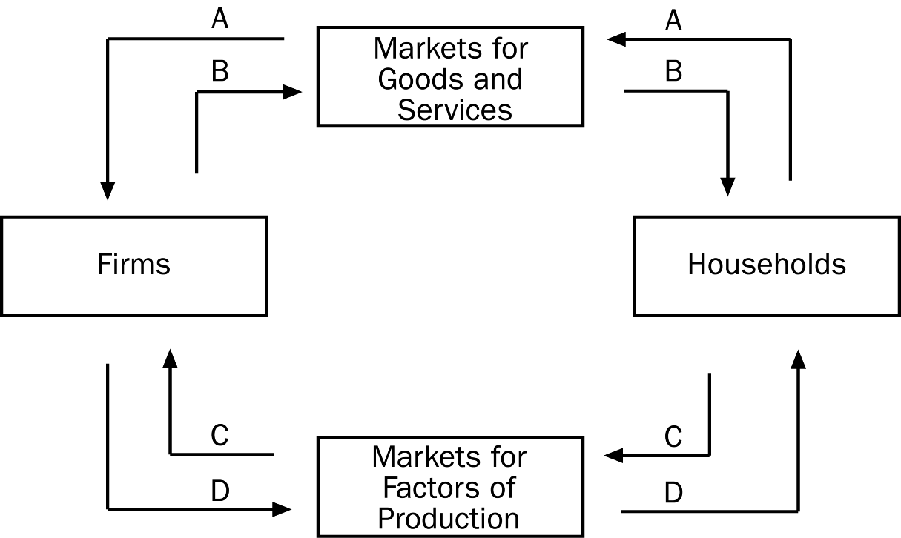
b. are buyers and firms are sellers.
c and firms are both buyers.
d and firms are both sellers.
ANSWER: a. are sellers and firms are buyers.
TYPE: M SECTION: 1 DIFFICULTY: 2
54. In the circular-flow diagram shown, which arrow shows the flow of goods and services?
a. A
b. B
c. C
d. D
ANSWER: b. B
TYPE: M SECTION: 1 DIFFICULTY: 2
55. In the circular-flow diagram shown, which arrow shows the flow of spending by households?
a. A
b. B
c. C
d. D
ANSWER: a. A
TYPE: M SECTION: 1 DIFFICULTY: 2
56. In the circular-flow diagram shown, which arrow shows the flow of the factors of production?
a. A
b. B
c. C
d. D
ANSWER: c. C
TYPE: M SECTION: 1 DIFFICULTY: 2
57. In the circular-flow diagram shown, which arrow shows the flow of income payments?
a. A
b. B
c. C
d. D
ANSWER: d. D
TYPE: M SECTION: 1 DIFFICULTY: 2

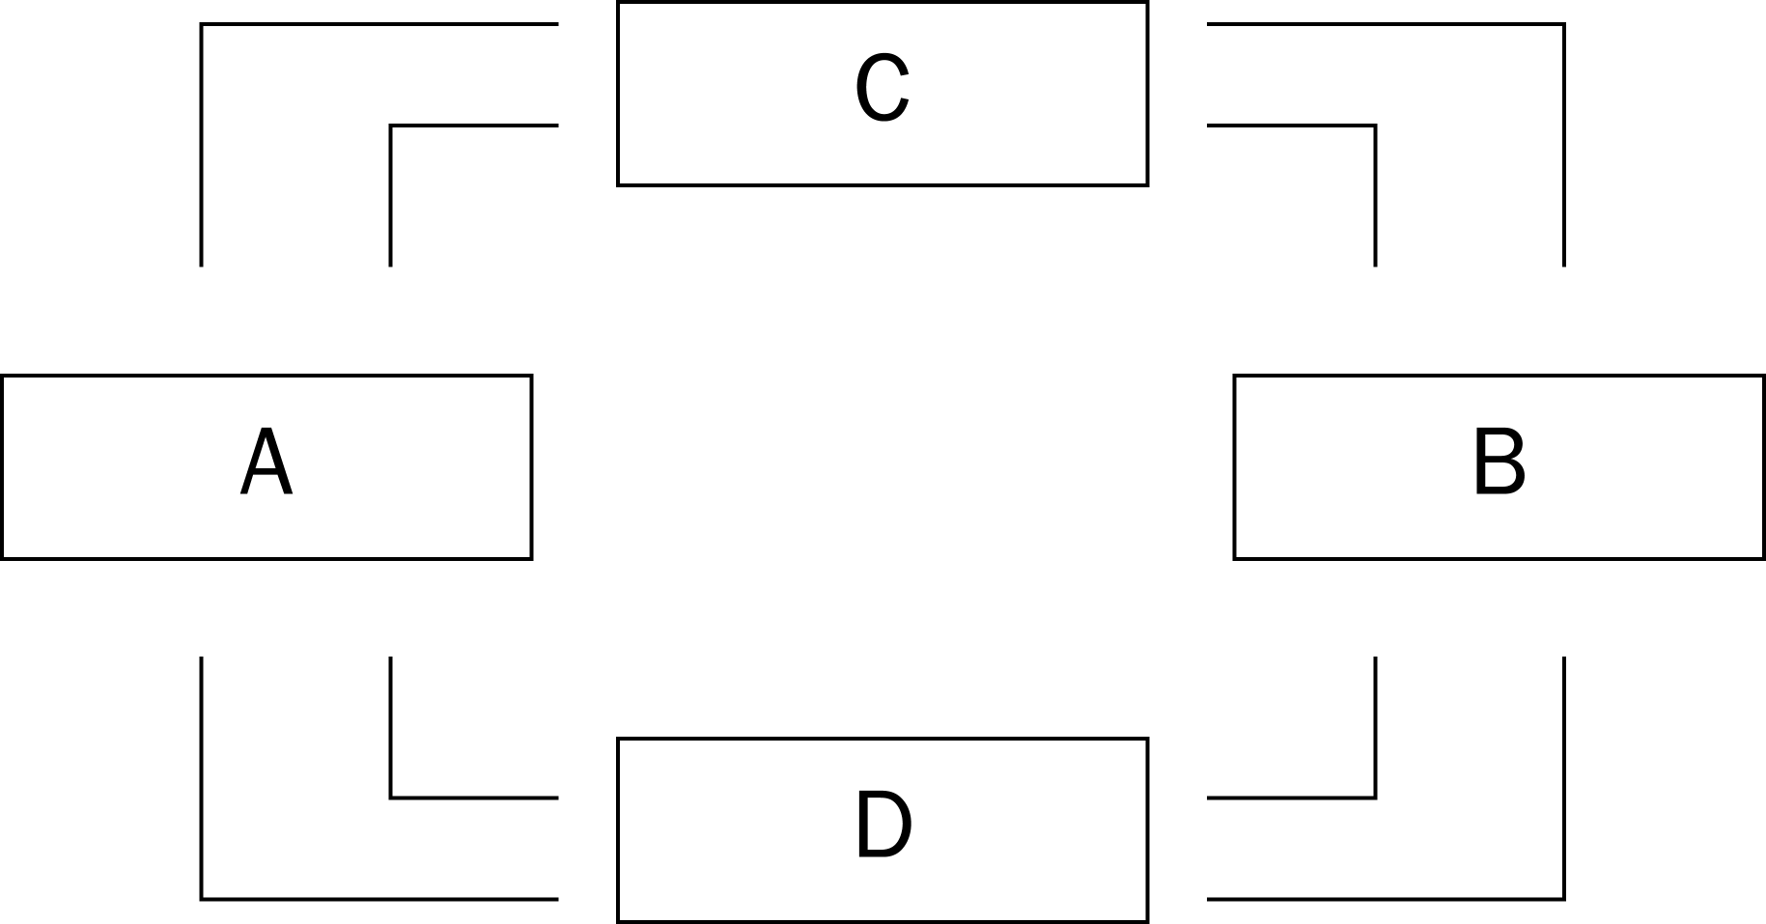

58. In the circular-flow diagram shown, boxes A and B represent
a. firms and households.
b. government and the foreign sector.
c. the goods and services market and the factors of production market.
d. households and government.
ANSWER: a. firms and households.
TYPE: M SECTION: 1 DIFFICULTY: 3
59. In the circular-flow diagram shown, boxes C and D represent
a. households and firms.
b. the goods and services market and the factors of production market.
c. the goods and services market and the financial market.
d. households and government.
ANSWER: b. the goods and services market and the factors of production market.
TYPE: M SECTION: 1 DIFFICULTY: 3
60. In the circular-flow diagram, households are sellers in
a. the factors of production market.
b. the goods and services market.
c. both markets.
d. neither market.
ANSWER: a. the factors of production market.
TYPE: M SECTION: 1 DIFFICULTY: 1
61. In the circular-flow diagram, firms are sellers in
a. the goods and services market.
b. the factors of production market.
c. both markets.
d. neither market.
ANSWER: a. the goods and services market.
TYPE: M SECTION: 1 DIFFICULTY: 1
62. According to the circular-flow diagram, factors of production are owned by
a. the government.
b. firms.
c. households.
d. All of the above are correct.
ANSWER: c. households.
TYPE: M SECTION: 1 DIFFICULTY: 1
63. In the circular-flow diagram, the inner loop represents the flow of
a. inputs to firms and output to households.
b. output to firms and inputs to households.
c. spending to firms and factor payments to households.
d. spending to households and factor payments to firms.
ANSWER: a. inputs to firms and output to households.
TYPE: M SECTION: 1 DIFFICULTY: 3
64. In the circular-flow diagram, the outer loop represents the flow of
a. goods and services.
b. spending.
c. factors of production.
d. All of the above are correct.
ANSWER: b. spending.
TYPE: M SECTION: 1 DIFFICULTY: 2
65. In the circular-flow diagram, money spent by households
a. is earned from the sale of factors of production.
b. becomes profit to firms.
c. cannot be tracked in the diagram.
d. is used to purchase factors of production.
ANSWER: a. is earned from the sale of factors of production.
TYPE: M SECTION: 1 DIFFICULTY: 2
66. In the markets for factors of production,
a. households provide firms with labor, land, and capital.
b. households provide firms with savings for investment.
c. firms provide households with goods and services.
d. the government provides firms with inputs for the production process.
ANSWER: a. households provide firms with labor, land, and capital.
TYPE: M SECTION: 1 DIFFICULTY: 2
67. In the markets for goods and services,
a. households provide firms with savings for investment.
b. households provide firms with labor, land, and capital.
c. firms provide households with the output they produced.
d. the government provides firms with inputs for the production process.
ANSWER: c. firms provide households with the output they produced.
TYPE: M SECTION: 1 DIFFICULTY: 2
68. The four sectors in a more complex circular-flow diagram include
a. households, government, financial markets, and international trade.
b. households, firms, government, and financial markets.
c. households, firms, financial markets, and international trade.
d. households, firms, government, and international trade.
ANSWER: d. households, firms, government, and international trade.
TYPE: M SECTION: 1 DIFFICULTY: 2
69. In economics, capital refers to
a. the finances necessary for firms to produce their products.
b. buildings and machines used in the production process.
c. the money households use to purchase firms’ output.
d. the city where firms must apply for the business license in their state.
ANSWER: b. buildings and machines used in the production process.
TYPE: M SECTION: 1 DIFFICULTY: 2
70. Revenue received by firms from sales which is not used to pay for factors of production is called
a. rent.
b. wages.
c. profit.
d. interest.
ANSWER: c. profit.
TYPE: M SECTION: 1 DIFFICULTY: 2
71. Any point on a country’s production possibilities frontier represents a combination of two goods that an economy
a. will never be able to produce.
b. can produce using all available resources and technology.
c. can produce using some of its resources and technology.
d. may be able to produce sometime in the future with additional resources and technology.
ANSWER: b. can produce using all available resources and technology.
TYPE: M SECTION: 1 DIFFICULTY: 3
72. The production possibilities frontier is a
a. map which shows the frontier beyond which agriculture is unprofitable.
b. map which shows areas of the world in which capitalist production is now possible.
c. graph which shows the various combinations of resources that can be used to produce a given level of output.
d. graph that shows the various combinations of output the economy can possibly produce given the available resources and technology.
ANSWER: d. graph that shows the various combinations of output the economy can possibly produce given the available resources and technology.
TYPE: M SECTION: 1 DIFFICULTY: 2
73. Which of the following is the most accurate statement about production possibilities?
a. An economy can produce only on the production possibilities frontier.
b. An economy can produce at any point inside or outside a production possibilities frontier.
c. An economy can produce at any point on or inside the production possibilities frontier, but not outside the frontier.
d. An economy can produce at any point inside the production possibilities frontier, but not on or outside the frontier.
ANSWER: c. An economy can produce at any point on or inside the production possibilities frontier, but not outside the frontier.
TYPE: M SECTION: 1 DIFFICULTY: 3
74. An economic outcome is said to be efficient if the economy is
a. using all of the resources it has available.
b. conserving on resources and not using all it has.
c. getting all it can from the scarce resources it has available.
d. able to produce more than its current production without additional resources.
ANSWER: c. getting all it can from the scarce resources it has available.
TYPE: M SECTION: 1 DIFFICULTY: 2
75. When constructing a production possibilities frontier, all of the following are assumptions EXCEPT
a. the economy produces only 2 goods.
b. all the economy’s factors of production are being used.
c. the economy has a fixed level of technology.
d. the economy may increase its available factors of production.
ANSWER: d. the economy may increase its available factors of production.
TYPE: M SECTION: 1 DIFFICULTY: 2
76. On a production possibilities frontier, production is efficient if the production point is
a. on the frontier.
b. outside the frontier.
c. on or inside the frontier.
d. inside the frontier.
ANSWER: a. on the frontier.
TYPE: M SECTION: 1 DIFFICULTY: 2
77. If an economy is producing efficiently
a. there is no way to produce more of one good without producing less of the other.
b. it is possible to produce more of both goods.
c. it is possible to produce more of one good without producing less of the other.
d. it is not possible to produce more of one good at any cost.
ANSWER: a. there is no way to produce more of one good without producing less of the other.
TYPE: M SECTION: 1 DIFFICULTY: 2
78. Which of the following concepts is NOT illustrated by the production possibilities frontier?
a. efficiency
b. opportunity cost
c. equity
d. tradeoffs
ANSWER: c. equity
TYPE: M SECTION: 1 DIFFICULTY: 2
79. The curved shape of the production possibilities frontier can be explained by
a. increasing cost of production.
b. constant cost of production.
c. scarcity.
d. economic growth.
ANSWER: a. increasing cost of production.
TYPE: M SECTION: 1 DIFFICULTY: 1
80. When a production possibilities frontier is linear it shows
a. a truer picture of real life than a bowed out production possibilities frontier.
b. that resources are perfectly shiftable from the production of one good to another.
c. an example of increasing opportunity cost.
d. All of the above are correct.
ANSWER: b. that resources are perfectly shiftable from the production of one good to another.
TYPE: M SECTION: 1 DIFFICULTY: 2
81. Suppose a nation is currently producing at a point inside its production possibilities frontier. We know that
a. the nation is producing beyond its capacity, and inflation will occur.
b. the nation is not using all available resources or has inefficiencies.
c. the nation is producing an efficient combination of goods.
d. there will be a large opportunity cost if the nation tries to increase production.
ANSWER: b. the nation is not using all available resources or has inefficiencies.
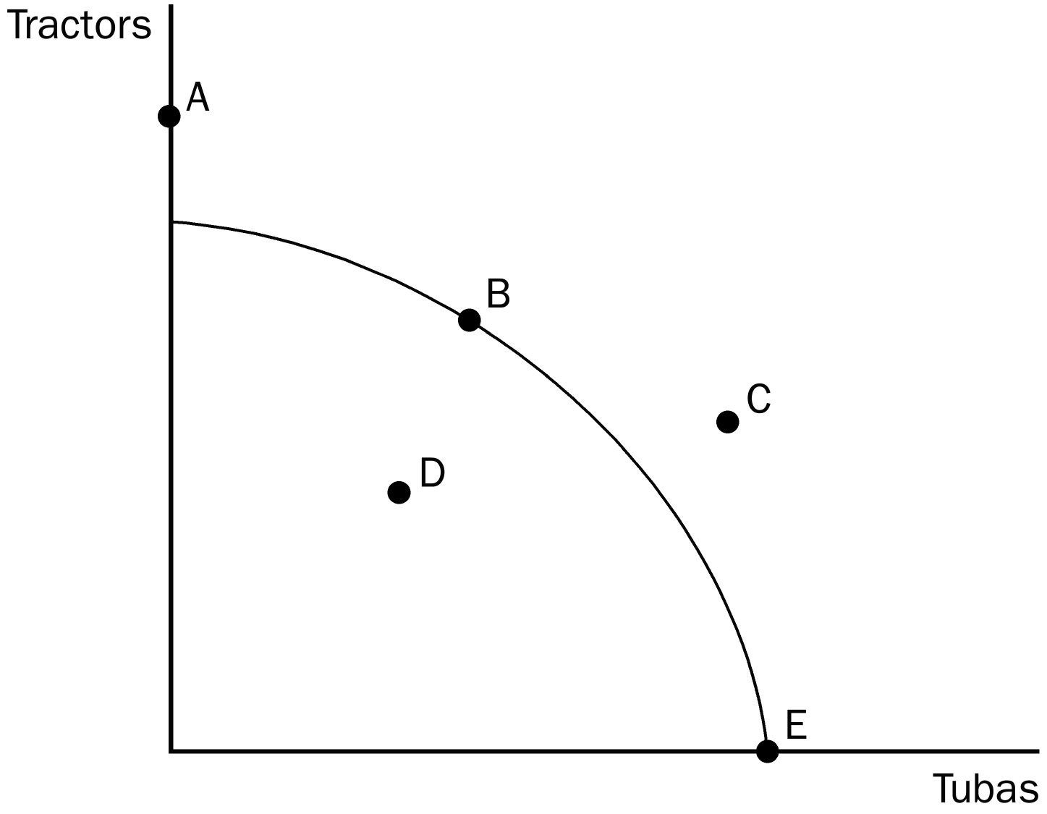
TYPE: M SECTION: 1 DIFFICULTY: 2
82. On the production possibilities frontier shown, the economy can produce at which point or points?
a. B, D, E
b. A, B, D, E
c. D, C
d. D
ANSWER: a. B, D, E
TYPE: M SECTION: 1 DIFFICULTY: 2
83. On the production possibilities frontier shown, which point represents the maximum possible production of tubas?
a. A
b. B
c. D
d. E
ANSWER: d. E.
TYPE: M SECTION: 1 DIFFICULTY: 2
84. On the production possibilities frontier shown, the economy CANNOT produce at which point or points?
a. A
b. C
c. A, C
d. A, C, D,
ANSWER: c. A, C
TYPE: M SECTION: 1 DIFFICULTY: 3
85. On the production possibilities frontier shown, which point or points are efficient?
a. B, E
b. A, B, E
c. D
d. C
ANSWER: a. B, E
TYPE: M SECTION: 1 DIFFICULTY: 3
86. On the production possibilities frontier shown, which point or points are inefficient?
a. A, C
b. D, C
c. C
d. D
ANSWER: d. D
TYPE: M SECTION: 1 DIFFICULTY: 2
87. The opportunity cost of obtaining more of one good is shown on the production possibilities frontier as the
a. amount of the other good that must be given up.
b. market price of the additional amount produced.
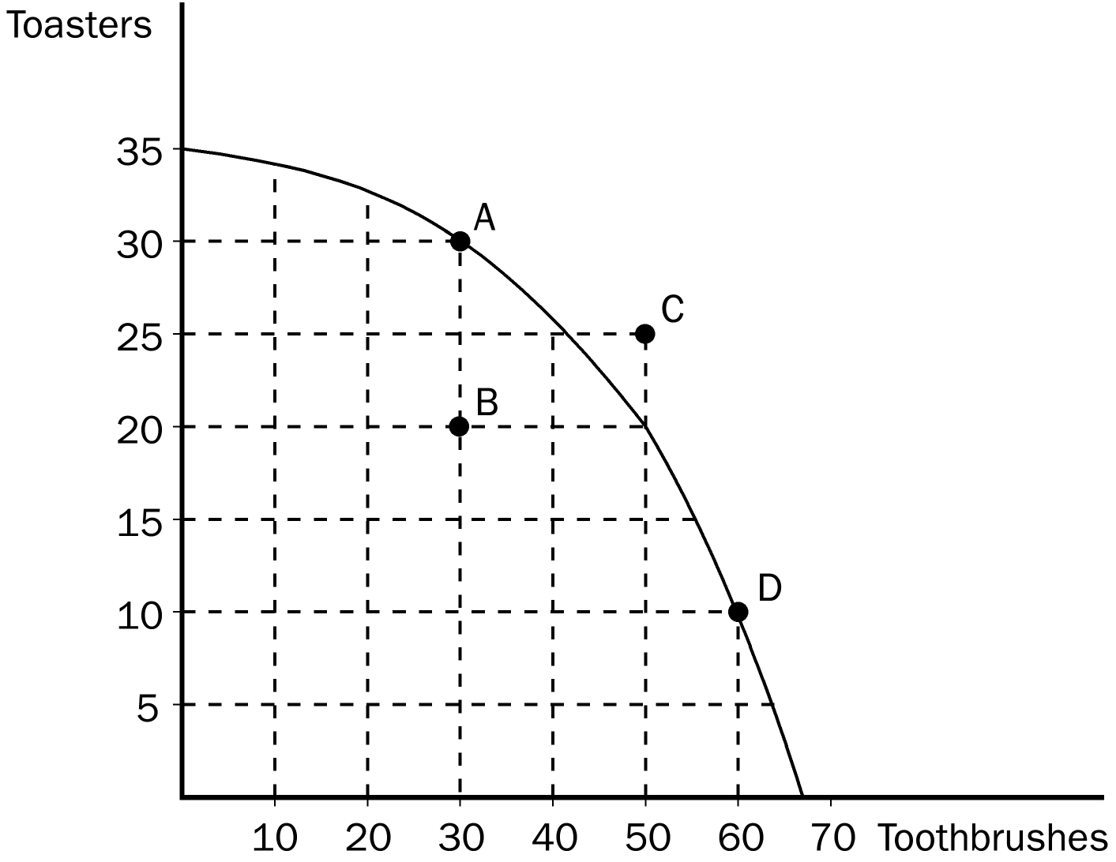
c. amount of resources that must be devoted to its production.
d. number of dollars that must be spent to produce it.
ANSWER: a. amount of the other good that must be given up.
TYPE: M SECTION: 1 DIFFICULTY: 2
88. On the production possibilities frontier shown, the opportunity cost to the economy of getting 30 additional toothbrushes by moving from point A to point D is
a. 10 toasters.
b. 15 toasters.
c. 20 toasters.
d. 25 toasters.
ANSWER: c. 20 toasters.
TYPE: M SECTION: 1 DIFFICULTY: 2
89. On the production possibilities frontier shown, the opportunity cost of getting 15 additional toasters by moving from point D to point C is
a. 10 toothbrushes.
b. 20 toothbrushes.
c. 30 toothbrushes.
d. It is impossible for the economy to move from point D to point C.
ANSWER: d. It is impossible for the economy to move from point D to point C.
TYPE: M SECTION: 1 DIFFICULTY: 3
90. On the production possibilities frontier shown, the opportunity cost in terms of toothbrushes of getting 10 additional toasters by moving from point B to point A is
a. 20 toothbrushes.
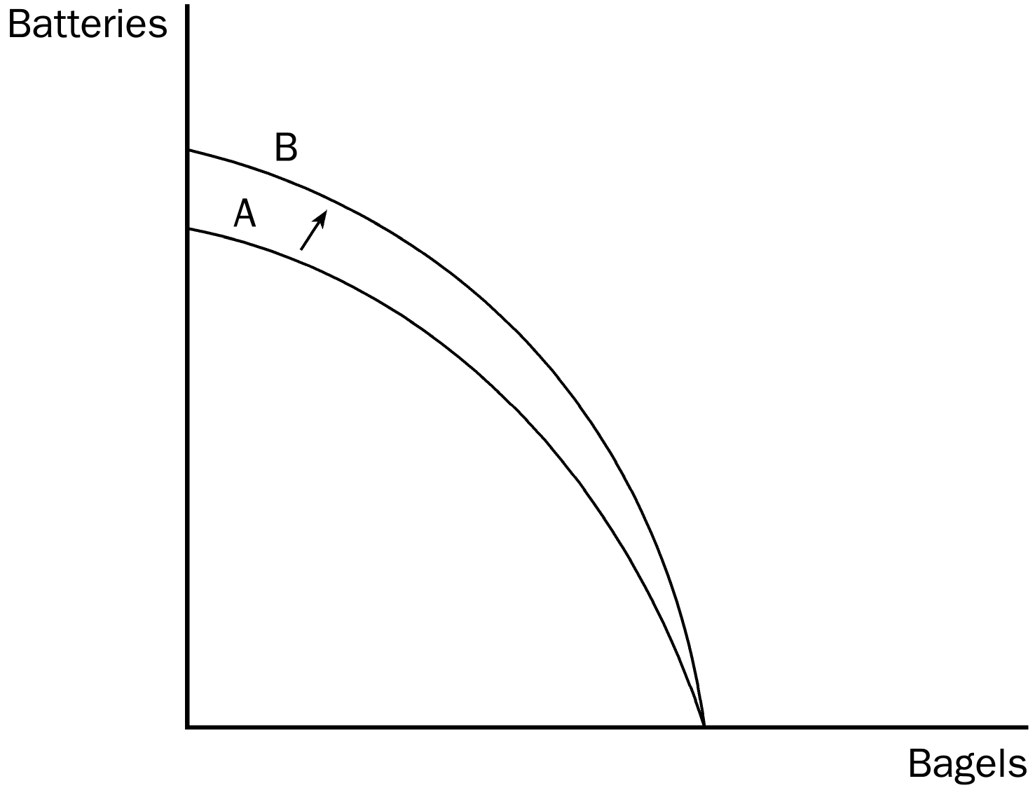
b. 10 toothbrushes.
c. 5 toothbrushes.
d. zero, since the economy has the additional resources to produce 10 additional toasters.
ANSWER: d. zero, since the economy has the additional resources to produce 10 additional toasters.
TYPE: M SECTION: 1 DIFFICULTY: 3
91. In the production possibilities frontier shown, the shift of the frontier from A to B was most likely caused by which of the following?
a. technological improvement in the production of batteries
b. more labor available in the economy
c. a general technological breakthrough
d. more capital available in the economy
ANSWER: a. technological improvement in the production of batteries
TYPE: M SECTION: 1 DIFFICULTY: 2

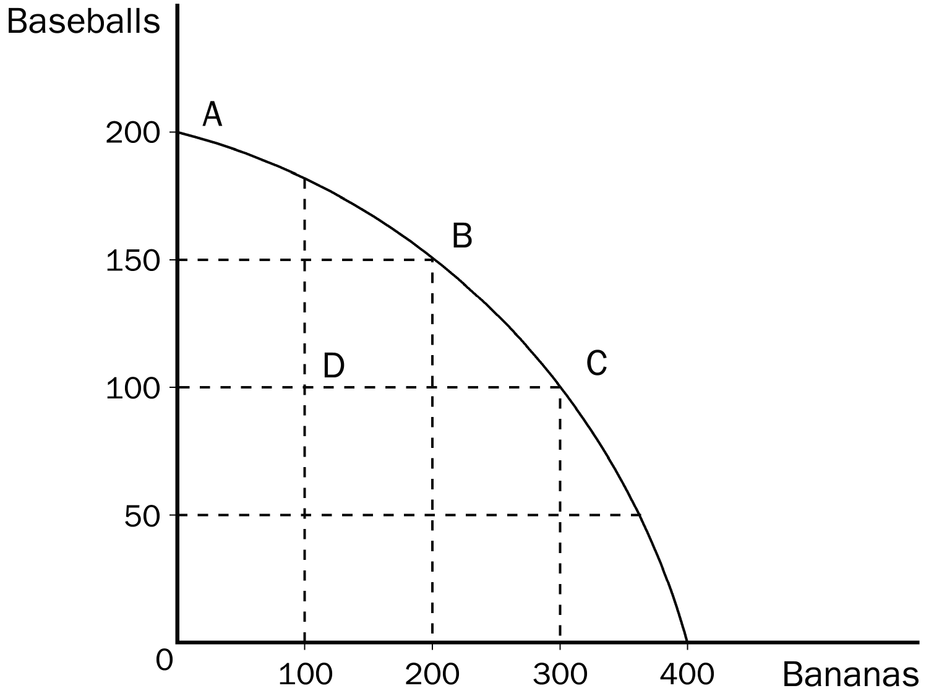
92. In the production possibilities frontier shown, what is the opportunity cost to society of the movement from point A to point C?
a. 50 baseballs
b. 100 baseballs
c. 100 bananas
d. 300 bananas
ANSWER: b. 100 baseballs
TYPE: M SECTION: 1 DIFFICULTY: 2
93. In the production possibilities frontier shown, what is the opportunity cost to society of moving from point B to point D?
a. 100 bananas
b. 50 baseballs
c. both 100 bananas and 50 baseballs
d. Nothing, since this economy would have unused resources.
ANSWER: c. both 100 bananas and 50 baseballs.
TYPE: M SECTION: 1 DIFFICULTY: 2
94. In the production possibilities frontier shown, the movement from point C to point D was most likely caused by
a. unemployment.
b. a decrease in society’s preference for bananas.
c. fewer resources available for production.
d. All of the above are correct.
ANSWER: a. unemployment.
TYPE: M SECTION: 1 DIFFICULTY: 2
95. According to the graph, if this economy put all available resources into the production of bananas, it could produce
a. 200 bananas and also 150 baseballs.
b. 300 bananas and also 100 baseballs.
c. 400 bananas and no baseballs.
d. It is impossible to know unless we know the quantity of resources available.
ANSWER: c. 400 bananas and no baseballs.
TYPE: M SECTION: 1 DIFFICULTY: 2
96. Production possibilities frontiers can shift outward if
a. government increases the amount of money in the economy.
b. there is an increase in technology.
c. resources can be moved from the production of one good to another.
d. Both b and c are correct.
ANSWER: b. there is an increase in technology.
TYPE: M SECTION: 1 DIFFICULTY: 2
97. The production possibilities frontier is bowed outward if
a. resources are not perfectly shiftable.
b. the amount of resources increases.
c. the level of technology increases.
d. Both b and c are correct
ANSWER: a. resources are not perfectly shiftable.
TYPE: M SECTION: 1 DIFFICULTY: 2
98. When a production possibilities frontier shifts outward, it is demonstrating the concept of
a. tradeoffs.
b. efficiency.
c. economic growth.
d. opportunity cost.
ANSWER: c. economic growth.
TYPE: M SECTION: 1 DIFFICULTY: 2
99. When an economy is operating inside its production possibilities frontier we know that
a. there are unused resources or inefficiencies in the economy.
b. the economy is operating with efficiency.
c. moving to a point on its production possibilities frontier would be economic growth.
d. to produced more of one good, the economy would have to give up some of the other good.
ANSWER: a. there are unused resources or inefficiencies in the economy.
TYPE: M SECTION: 1 DIFFICULTY: 2
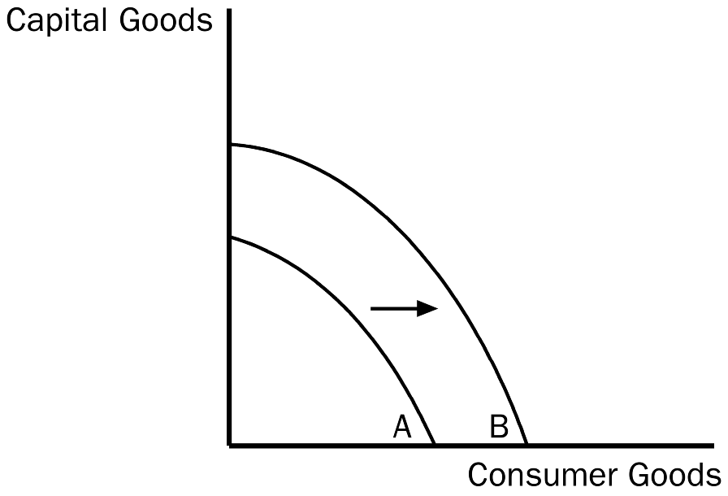
100. Which of the following would most likely have caused the production possibilities frontier to shift outward from A to B in the graph shown?
a. an increase in resources necessary to produce capital goods
b. an improvement in the technology of producing consumer goods
c. an increase in the overall level of technology in the economy
d. an increase in unemployment
ANSWER: c. an increase in the overall level of technology in the economy
TYPE: M SECTION: 1 DIFFICULTY: 2
101. In the graph shown, the movement from frontier A to B can best be described as
a. a downturn in the economy.
b. economic growth.
c. a more equitable distribution of income.
d. an improvement in the allocation of resources.
ANSWER: b. economic growth.
TYPE: M SECTION: 1 DIFFICULTY: 2
102. Unemployment would cause an economy to
a. produce inside its production possibilities frontier.
b. produce on its production possibilities frontier.
c. produce outside its production possibilities frontier.
d. unemployment could actually cause a, b, or c, depending on how severe it is.
ANSWER: a. produce inside its production possibilities frontier.
TYPE: M SECTION: 1 DIFFICULTY: 2

Production Possibilities for Toyland

Dolls | Fire Trucks
400 | 0
300 | 200
200 | 350
100 | 450
0 | 500

103. Given the table shown, what is the opportunity cost to Toyland of increasing the production of dolls from 200 to 300?
a. 200 fire trucks
b. 150 fire trucks
c. 100 fire trucks
d. It is impossible to tell what the opportunity cost is since in this example costs are not constant.
ANSWER: b. 150 fire trucks.
TYPE: M SECTION: 1 DIFFICULTY: 2
104. Given the table shown, which of the following statements accurately describes the production possibilities for Toyland?
a. The opportunity cost of an additional 100 dolls is 50 fire trucks.
b. The opportunity cost of an additional 100 dolls is 100 fire trucks.
c. Without additional information, it is impossible to determine the opportunity cost of an additional doll.
d. The opportunity cost of an additional 100 dolls increases as more dolls are produced.
ANSWER: d. The opportunity cost of an additional 100 dolls increases as more dolls are produced.
TYPE: M SECTION: 1 DIFFICULTY: 2
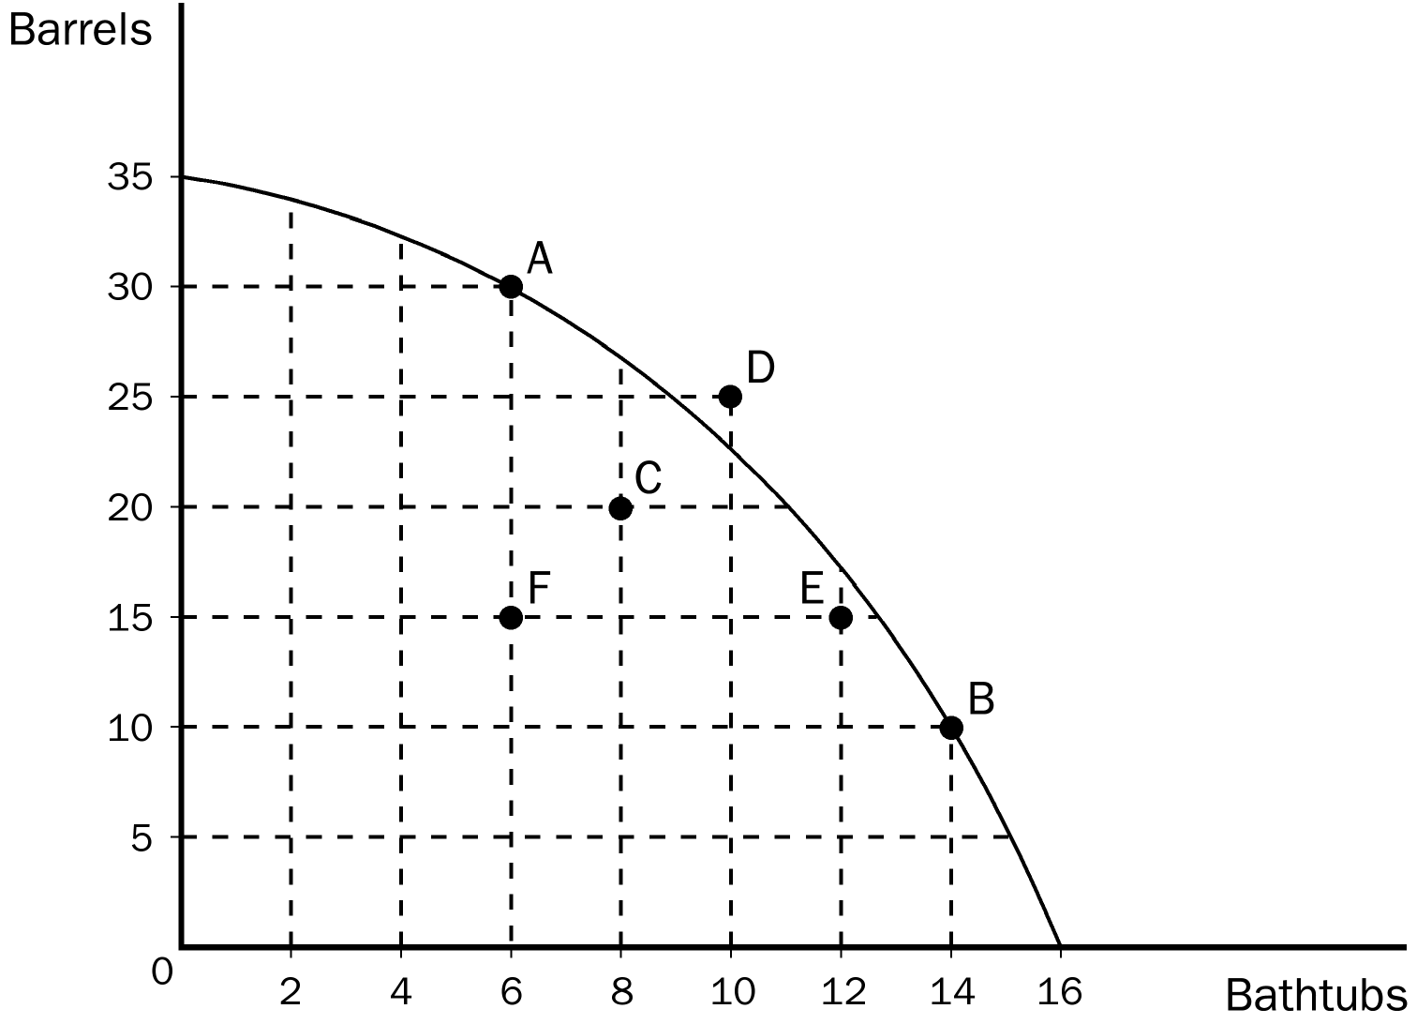
105. According to the graph, an efficient combination of bathtubs and barrels would be
a. 30 barrels and 6 bathtubs.
b. 20 barrels and 8 bathtubs.
c. 25 barrels and 12 bathtubs.
d. 15 barrels and 12 bathtubs.
ANSWER: a. 30 barrels and 6 bathtubs.
TYPE: M SECTION: 1 DIFFICULTY: 3
106. According to the graph, what is the opportunity cost of moving from point A to point B?
a. 8 bathtubs
b. 20 barrels
c. the difference between the 8 bathtubs you get and the 20 barrels you give up
d. the difference between the 20 barrels you get and the 8 bathtubs you give up
ANSWER: b. 20 barrels
TYPE: M SECTION: 1 DIFFICULTY: 3
107. According to the graph, if this economy puts all of its resources into the production of bathtubs it could produce
a. 20 barrels and 12 bathtubs.
b. 35 barrels and no bathtubs.
c. no barrels and 16 bathtubs.
d. This economy would not choose to put all of its resources into the production of one good.
ANSWER: c. no barrels and 16 bathtubs.
TYPE: M SECTION: 1 DIFFICULTY: 2
108. According to the graph, which of the following combinations is impossible for this economy to produce?
a. 30 barrels and 6 bathtubs
b. 25 barrels and 12 bathtubs
c. 20 barrels and 8 bathtubs
d. 10 barrels and 14 bathtubs
ANSWER: b. 25 barrels and 12 bathtubs
TYPE: M SECTION: 1 DIFFICULTY: 3
109. According to the graph, if this economy moved from point C to point E,
a. it still would not be producing efficiently.
b. there would be no gain in either bathtubs or barrels.
c. it would be producing more barrels and more bathtubs than at point C.
d. It is not possible for this economy to move from point C to point E without additional resources.
ANSWER: a. it still would not be producing efficiently.
TYPE: M SECTION: 1 DIFFICULTY: 3
110. The field of economics is traditionally divided into two broad subfields,
a. national economics and international economics.
b. consumer economics and producer economics.
c. private sector economics and public sector economics.
d. microeconomics and macroeconomics.
ANSWER: d. microeconomics and macroeconomics.
TYPE: M SECTION: 1 DIFFICULTY: 1
111. Microeconomics is the study of
a. the behavior of consumers.
b. how individual households and firms make decisions.
c. how government affects the economy.
d. how the economy as a whole works.
ANSWER: b. how individual households and firms make decisions.
TYPE: M SECTION: 1 DIFFICULTY: 1
112. Macroeconomics is the study of
a. individual decisionmakers.
b. economic history.
c. economy-wide phenomena.
d. how firms maximize profit.
ANSWER: c. economy-wide phenomena.
TYPE: M SECTION: 1 DIFFICULTY: 1
113. Which of the following would be considered a topic of study in macroeconomics?
a. the impact of agricultural price support programs in the cotton industry
b. the effect on U.S. steel producers of an import quota imposed on foreign steel
c. the effect of an increase in the price of imported oil on the U.S. inflation rate
d. the effect of an increase in the price of imported coffee beans on the U.S. coffee industry
ANSWER: c. the effect of an increase in the price of imported oil on the U.S. inflation rate
TYPE: M SECTION: 1 DIFFICULTY: 2
114. A microeconomist might study each of the following EXCEPT
a. the effects of rent control on housing in New York City.
b. how a college student makes financial decisions.
c. how tariffs on shoes affects the shoe industry.
d. the effect on the economy when unemployment rates change.
ANSWER: d. the effect on the economy when unemployment rates change.
TYPE: M SECTION: 1 DIFFICULTY: 2
115. A macroeconomist would study each of the following EXCEPT the
a. impact of minimum-wage laws on employment in the fast food industry.
b. effect of changes in saving rates on GDP.
c. impact of monetary policy on the rate of inflation.
d. effect of tax policy on the rate of economic growth.
ANSWER: a. impact of minimum-wage laws on employment in the fast-food industry.
TYPE: M SECTION: 1 DIFFICULTY: 2
116. Which of the following is true?
a. Microeconomics and macroeconomics are two separate divisions of economics, independent of each other.
b. It is possible to understand macroeconomics without understanding microeconomics, but not vice versa.
c. Microeconomics and macroeconomics are two distinct but closely intertwined fields of economics.
d. Microeconomics and macroeconomics are two different names for basically the same thing in economics.
ANSWER: c. Microeconomics and macroeconomics are two distinct but closely intertwined fields of economics.
TYPE: M SECTION: 1 DIFFICULTY: 2
117. When economists are trying to explain the world they are
a. scientists.
b. policy advisors.
c. in the realm of normative economics.
d. in over their heads.
ANSWER: a. scientists.
TYPE: M SECTION: 1 DIFFICULTY: 1
118. When economists are trying to help improve the world they are
a. concerned with positive economics.
b. policy advisors.
c. scientists.
d. meddling.
ANSWER: b. policy advisors.
TYPE: M SECTION: 1 DIFFICULTY: 1
119. Which is the best statement about the roles of economists?
a. Economists are best viewed as policymakers.
b. Economists are best viewed as scientists.
c. In trying to explain the world, economists are policymakers; in trying to improve the world, they are scientists.
d. In trying to explain the world, economists are scientists; in trying to improve the world, they are policymakers.
ANSWER: d. In trying to explain the world, economists are scientists; in trying to improve the world, they are policymakers.
TYPE: M SECTION: 2 DIFFICULTY: 2
120. For economists, statements about the world are of two types:
a. assumptions and theories.
b. true statements and false statements.
c. specific statements and general statements.
d. positive statements and normative statements.
ANSWER: d. positive statements and normative statements.
TYPE: M SECTION: 2 DIFFICULTY: 1
121. Economists view positive statements as
a. affirmative, justifying existing economic policy.
b. optimistic, putting the best possible interpretation on things.
c. descriptive, making a claim about how the world is.
d. prescriptive, making a claim about how the world ought to be.
ANSWER: c. descriptive, making a claim about how the world is.
TYPE: M SECTION: 2 DIFFICULTY: 2
122. Economists consider normative statements to be
a. descriptive, making a claim about how the world is.
b. statements about the normal condition of the world.
c. prescriptive, making a claim about how the world ought to be.
d. statements which establish production goals for the economy.
ANSWER: c. prescriptive, making a claim about how the world ought to be.
TYPE: M SECTION: 2 DIFFICULTY: 2
123. Which of the following is an example of a positive statement?
a. Prices rise when the government prints too much money.
b. If welfare payments increase, the world will be a better place.
c. Inflation is more harmful to the economy than unemployment.
d. The benefits to the economy of improved equity are greater than the costs of reduced efficiency.
ANSWER: a. Prices rise when the government prints too much money.
TYPE: M SECTION: 2 DIFFICULTY: 2
124. A normative statement describes how the world
a. was in the past.
b. is.
c. will be in the future.
d. ought to be.
ANSWER: d. ought to be.
TYPE: M SECTION: 2 DIFFICULTY: 1
125. Which of the following is an example of a normative statement?
a. If the price of a product decreases, quantity demanded increases.
b. Reducing tax rates on the wealthy would be good for the country.
c. If the national saving rate were to increase, so would the rate of economic growth.
d. All of the above are correct.
ANSWER: b. Reducing tax rates on the wealthy would be good for the country.
TYPE: M SECTION: 2 DIFFICULTY: 2
126. “Prices rise when the government prints too much money” is an example of a
a. positive economic statement.
b. statement made by the Carter administration.
c. normative economic statement.
d. welfare statement.
ANSWER: a. positive economic statement.
TYPE: M SECTION: 2 DIFFICULTY: 2
127. Economists from the Treasury Department provide
a. the annual Economic Report of the President.
b. Congress with the annual budget.
c. enforcement of the U. S. Antitrust laws.
d. advice on tax policy to the President.
ANSWER: d. advice on tax policy to the President.
TYPE: M SECTION: 2 DIFFICULTY: 1
128. When economists are speaking as policy advisors, they are more likely to use
a. normative statements.
b. positive statements.
c. objective statements.
d. All of the above are correct.
ANSWER: a. normative statements.
TYPE: M SECTION: 2 DIFFICULTY: 1
129. Evaluating a positive statement involves
a. evaluating values as well as facts.
b. examining evidence.
c. our views on ethics and religion.
d. All of the above are correct.
ANSWER: b. examining evidence.
TYPE: M SECTION: 2 DIFFICULTY: 1
130. You know an economist has crossed the line from scientist to policy adviser when he
a. explains just the facts.
b. makes positive statements.
c. makes normative statements.
d. can’t reach a conclusion.
ANSWER: c. makes normative statements.
TYPE: M SECTION: 2 DIFFICULTY: 1
131. In addition to advising the president, one duty of the Council of Economic Advisors is to
a. prepare the federal budget.
b. write government regulations.
c. advise Congress on economic matters.
d. write the annual Economic Report of the President.
ANSWER: d. write the annual Economic Report of the President.
TYPE: M SECTION: 2 DIFFICULTY: 2
132. The Council of Economic Advisors consists of
a. three members and a staff of several dozen economists.
b. six members and a staff of several dozen economists.
c. twelve members and a staff of about a hundred economists.
d. several dozen members and a staff of several hundred economists.
ANSWER: a. three members and a staff of several dozen economists.
TYPE: M SECTION: 2 DIFFICULTY: 2
133. The President of the United States receives tax policy advice from economists in the
a. Federal Reserve.
b. Department of Justice.
c. Department of Treasury.
d. Congressional Budget Office.
ANSWER: c. Department of Treasury.
TYPE: M SECTION: 2 DIFFICULTY: 2
134. Economists in which department help enforce antitrust laws?
a. Department of Labor
b. Department of Justice
c. Department of Treasury
d. Department of Commerce
ANSWER: b. Department of Justice
TYPE: M SECTION: 2 DIFFICULTY: 2
135. Economists who are primarily responsible for advising Congress on economic matters work in which agency?
a. the Federal Reserve
b. the Congressional Budget Office
c. the Department of Treasury
d. the Department of Commerce
ANSWER: b. the Congressional Budget Office
TYPE: M SECTION: 2 DIFFICULTY: 2
136. The President of the United States has received guidance from the Council of Economic Advisers since
a. 1932.
b. 1946.
c. 1955.
d. 1963.
ANSWER: b. 1946.
TYPE: M SECTION: 4 DIFFICULTY: 1
137. The Council of Economic Advisers has
a. 3 members and a staff of economists.
b. 5 members and a staff of economists.
c. 7 members and a staff of economists.
d. 9 members and a staff of economists.
ANSWER: a. 3 member and a staff of economists.
TYPE: M SECTION: 4 DIFFICULTY: 1
138. Duties of the Council of Economic Advisers include
a. advising the President.
b. designing tax policy.
c. write the annual Economic Report of the President.
d. All of the above are correct.
e. Both a and c are correct.
ANSWER: e. Both a and c are correct.
TYPE: M SECTION: 4 DIFFICULTY: 2
139. Tax policy is designed by the
a. Council of Economic Advisers.
b. Department of Treasury.
c. Department of Labor.
d. Department of Justice.
ANSWER: b. Department of Treasury.
TYPE: M SECTION: 4 DIFFICULTY: 1
140. The nation’s antitrust laws are enforced by the
a. Department of Labor.
b. Council of Economic Advisers.
c. Department of Justice.
d. Department of Treasury.
ANSWER: c. Department of Justice.
TYPE: M SECTION: 4 DIFFICULTY: 1
141. A duty of the Department of Labor is to
a. analyze data on workers.
b. design tax policy.
c. enforce the nation’s antitrust laws.
d. advise the President.
ANSWER: a. analyze data on workers.
TYPE: M SECTION: 4 DIFFICULTY: 1
142. The Federal Reserve
a. designs tax policy.
b. enforces the nation’s antitrust laws.
c. sets the nation’s monetary policy.
d. analyzes the data on workers.
ANSWER: c. sets the nation’s monetary policy.
TYPE: M SECTION: 4 DIFFICULTY: 1
143. Congress relies on economists at the Congressional Budget Office to
a. enforce the nation’s antitrust laws.
b. analyze economic developments in the United States.
c. set the nation’s monetary policy.
d. obtain independent evaluations of policy proposals.
ANSWER: d. obtain independent evaluations of policy proposals.
TYPE: M SECTION: 4 DIFFICULTY: 1
144. Suppose that someone makes the argument that because empty alcohol containers are found at many accidents, the containers cause accidents. This would be an example of
a. sound logic.
b. reverse causality.
c. omitted variables.
d. slope.
ANSWER: c. omitted variables.
TYPE: M SECTION: 4 DIFFICULTY: 1
145. In the early 19th century, the Russian government sent doctors to southern Russian villages to provide assistance during a cholera epidemic. The villagers noticed that wherever doctors appeared, people died. Therefore, many doctors were chased away from villages, and some were even killed. This reaction to the correlation between doctors and deaths is most likely a problem of
a. omitted variables.
b. reverse causality.
c. government propaganda.
d. medical incompetence.
ANSWER: b. reverse causality.
TYPE: M SECTION: 4 DIFFICULTY: 1
146. One way to determine the direction of causality is to
a. assume the 2 variables move in the same direction.
b. assume the 2 variables move in opposite directions.
c. determine which variable moves first.
d. determine which variable is the dependent variable and which variable could be the independent variable.
ANSWER: c. determine which variable moves first.
TYPE: M SECTION: 4 DIFFICULTY: 2
147. Any economist that says all policy decisions are easy
a. must understand the relationship between a market economy and the government.
b. must be running for office.
c. has a Ph.D. in economics.
d. cannot be trusted.
ANSWER: d. cannot be trusted.
TYPE: M SECTION: 4 DIFFICULTY: 1
148. John Maynard Keynes believed the ideas of economists to be
a. generally incorrect.
b. powerful.
c. pie-in-the-sky ideals.
d. rantings of madmen.
ANSWER: b. powerful.
TYPE: M SECTION: 4 DIFFICULTY: 1
149. John Maynard Keynes referred to economics as an easy subject,
a. at which very few excel.
b. but not as easy as philosophy or the pure sciences.
c. which very few can enjoy.
d. which deals primarily with common sense.
ANSWER: a. at which very few excel.
TYPE: M SECTION: 4 DIFFICULTY: 1
150. George Bernard Shaw, among others, has criticized economists because
a. they have too much influence with government decisions.
b. many ideas are too theoretical and therefore do not work in “real life”.
c. they tend to speak a different language, causing most people to not understand them.
d. they seem to give conflicting advice to policymakers.
ANSWER: d. they seem to give conflicting advice to policymakers.
TYPE: M SECTION: 4 DIFFICULTY: 2
151. President Ronald Reagan’s Trivial Pursuit game for economists would have
a. no questions but hundreds of answers.
b. 100 questions and 3000 answers.
c. 1000 questions but no answers.
d. hundreds of questions but not answers that could apply to the questions asked.
ANSWER: b. 100 questions and 3000 answers.
TYPE: M SECTION: 4 DIFFICULTY: 1
152. The 2 basic reasons why economists often appear to give conflicting advice to policymakers are differences in
a. opinions and education.
b. scientific judgments and values.
c. scientific judgments and education.
d. opinions and values.
ANSWER: b. scientific judgments and values.
TYPE: M SECTION: 4 DIFFICULTY: 2
153. The 3 propositions about which most economists agree most often are (in order from first to third)
a. rent control, tariffs and quotas, and floating exchange rates.
b. tariffs and quotas, floating exchange rates, and fiscal policy.
c. rent control, fiscal policy, and tariffs and quotas.
d. fiscal policy, rent control, and floating exchange rates.
ANSWER: a. rent control, tariffs and quotas, and floating exchange rates.
TYPE: M SECTION: 4 DIFFICULTY: 3
154. Tariffs and quotas are
a. policies that restrict trade.
b. are implemented to increase trade efficiency.
c. opposed by almost all economists.
d. Both a and c are correct.
e. Both a and b are correct.
ANSWER: d. Both a and c are correct.
TYPE: M SECTION: 4 DIFFICULTY: 3
155. In 2002, the Bush administration imposed large tariffs to protect domestic
a. steel producers.
b. shoe producers.
c. wine producers.
d. clothing producers.
ANSWER: a. steel producers.
TYPE: M SECTION: 4 DIFFICULTY: 1
156. A survey which asked the opinion of academic, business, and government economists on ten propositions about economic policy found that
a. the respondents were almost equally divided on the propositions.
b. the respondents favored the propositions by a slight margin.
c. the respondents disagreed with the propositions by a slight margin.
d. there was overwhelming endorsement of the propositions among the respondents.
ANSWER: d. there was overwhelming endorsement of the propositions among the respondents.
TYPE: M SECTION: 3 DIFFICULTY: 2
157. Almost all economists agree that rent control
a. improves the availability and quality of housing.
b. allows the market for housing to work more efficiently.
c. adversely affects the availability and quality of housing.
d. is a very inexpensive way to help the most needy members of society.
ANSWER: c. adversely affects the availability and quality of housing.
TYPE: M SECTION: 3 DIFFICULTY: 2
158. Which of the following is the best explanation for why policies such as rent control and import quotas persist in spite of the fact that experts are united in their opposition to such policies?
a. Economists have not yet convinced the general public that the policies are undesirable.
b. Economists are simply wrong about the economic impact of these policies.
c. Economists have different values than do most people.
d. Economists are usually of a different political party than are lawmakers.
ANSWER: a. Economists have not yet convinced the general public that the policies are undesirable.
TYPE: M SECTION: 3 DIFFICULTY: 2
159. How did the great economist John Maynard Keynes explain his comment that although economics is an easy subject compared with the higher branches of philosophy or pure science, it is a subject at which few excel?
a. Most people who study economics are not very bright.
b. Good economists must possess a rare combination of gifts.
c. Economics is actually quite boring; hence, people tend to lose interest in it.
d. Good thinkers become frustrated with economics because it is not logical or relevant.
ANSWER: b. Good economists must possess a rare combination of gifts.
TYPE: M SECTION: 4 DIFFICULTY: 2
160. Economist use graphs to
a. find how variables are related in the real world.
b. express economic ideas that cannot be expressed with equations or words.
c. visually express ideas more clearly than might be the case if they are expressed with equations or words.
d. Both a and c are correct.
e. All of the above are correct.
ANSWER: d. Both a and c are correct.
TYPE: M SECTION: 4 DIFFICULTY: 2
161. A type of graph that can be used to display the relationship between two variables is
a. a pie chart.
b. a bar graph.
c. a time-series graph.
d. the coordinate system.
ANSWER: d. the coordinate system.
TYPE: M SECTION: 4 DIFFICULTY: 2
162. A coordinate system is used to
a. show the flow of income and products in an economic system.
b. organize labor and other resources in the production process.
c. allow economists to show two variables on a single graph.
d. teach economists how to draw graphs consistently.
ANSWER: c. allow economists to show two variables on a single graph.
TYPE: M SECTION: 4 DIFFICULTY: 2
163. An ordered pair is
a. the process of checking calculations twice before placing them on a graph.
b. two numbers which can be represented by a single point on a graph.
c. two numbers that are represented by side-by-side points on a graph.
d. two points on a graph which are equal distances from the origin.
ANSWER: b. two numbers which can be represented by a single point on a graph.
TYPE: M SECTION: 4 DIFFICULTY: 2
164. The ordered pair that represents the origin on a graph is
a. (1, 1).
b. (0, 0).
c. (0, 1).
d. (1, 0).
ANSWER: b. (0, 0).
TYPE: M SECTION: 4 DIFFICULTY: 2
165. The x-coordinate is the
a. first number of an ordered pair and represents the point’s horizontal location.
b. second number of an ordered pair and represents the point’s horizontal location.
c. first number of an ordered pair and represents the point’s vertical location.
d. second number of an ordered pair and represents the point’s vertical location.
ANSWER: a. first number of an ordered pair and represents the point’s horizontal location.
TYPE: M SECTION: 4 DIFFICULTY: 3
166. The y-coordinate is the
a. first number of an ordered pair and represents the point’s horizontal location.
b. second number of an ordered pair and represents the point’s horizontal location.
c. first number of an ordered pair and represents the point’s vertical location.
d. second number of an ordered pair and represents the point’s vertical location.
ANSWER: d. second number of an ordered pair and represents the point’s vertical location.
TYPE: M SECTION: 4 DIFFICULTY: 3
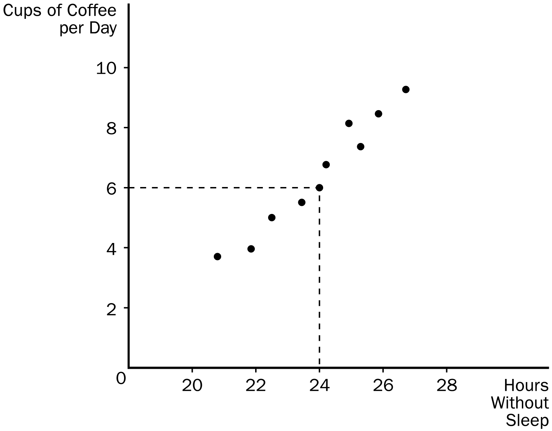
167. The graph shown is known as a
a. time series.
b. bar graph.
c. scatterplot.
d. pie chart.
ANSWER: c. scatterplot.
TYPE: M SECTION: 4 DIFFICULTY: 2
168. In the graph shown, the correct designation of point A is:
a. (6, 0)
b. (0, 24)
c. (6, 24)
d. (24, 6)
ANSWER: d. (24, 6)
TYPE: M SECTION: 4 DIFFICULTY: 2
169. According to the graph, cups of coffee per day and the hours that someone can go without sleep have
a. a positive correlation.
b. a negative correlation.
c. a random correlation.
d. no correlation.
ANSWER: a. a positive correlation.
TYPE: M SECTION: 4 DIFFICULTY: 2
170. Based on the graph shown, what would you say about the relationship between coffee and hours without sleep?
a. The less coffee a person drinks per day, the more time he can go without sleep.
b. There is no relationship between how much coffee per day a person drinks and how long they can go without sleep.
c. The more coffee a person drinks per day, the longer he can go without sleep.
d. The relationship between cups of coffee per day and time without sleep is too unpredictable to consider.
ANSWER: c. The more coffee a person drinks per day, the longer he can go without sleep.
TYPE: M SECTION: 4 DIFFICULTY: 3
171. In the graph, the curves shown are
a. supply curves.
b. demand curves.
c. preference curves.
d. income-consumption curves.
ANSWER: b. demand curves.
TYPE: M SECTION: 4 DIFFICULTY: 1
172. In the graph shown, the movement from point A to point B is a
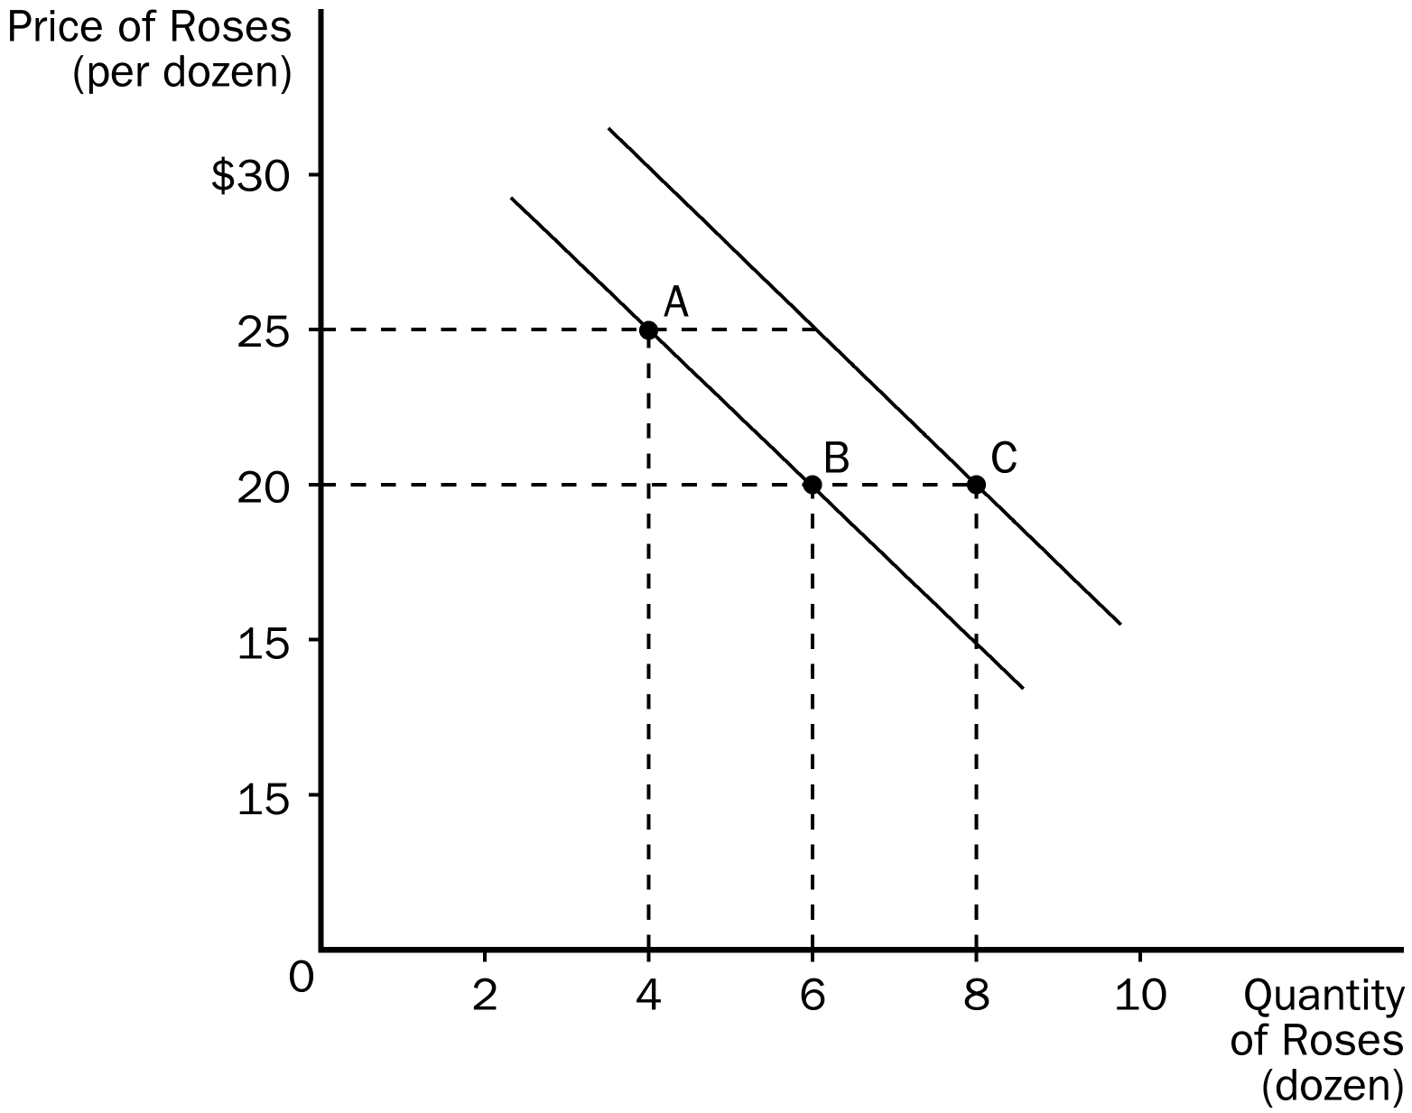
a. shift of the curve.
b. change in preferences.
c. movement along the curve.
d. All of the above are correct.
ANSWER: c. movement along the curve.
TYPE: M SECTION: 4 DIFFICULTY: 2
173. In the graph shown, the movement from point B to point C is a
a. shift of the curve.
b. change in price.
c. movement along the curve.
d. change in costs to the firm.
ANSWER: a. shift of the curve.
TYPE: M SECTION: 4 DIFFICULTY: 2
174. In the graph shown, the slope of the curve between points A and B is
a. 5/2
b. 2/5
c. –2/5
d. –5/2
ANSWER: d. –5/2
TYPE: M SECTION: 4 DIFFICULTY: 2
175. In the graph shown, the movement from point B to point C could have been caused by
a. inflation.
b. a change in income.
c. a change in the price of roses.
d. a change in the cost of producing roses.
ANSWER: b. a change in income.
TYPE: M SECTION: 4 DIFFICULTY: 3
176. In the graph shown, the price of roses and the quantity of roses are
a. directly related and therefore move in the same direction.
b. directly related and therefore move in opposite directions.
c. inversely related and therefore move in opposite directions.
d. independent of each other.
ANSWER: c. inversely related and therefore move in opposite directions.
TYPE: M SECTION: 4 DIFFICULTY: 3
177. The slope of a straight line is calculated by
a rise divided by run.
b. run divided by rise.
c. the average of rise and run.
d. rise plus run.
ANSWER: a. rise divided by run.
TYPE: M SECTION: 4 DIFFICULTY: 2
178. The slope of a line is calculated by
a. change in x/change in y.
b. change in y/change in x.
c. x/y.
d. x + y.
ANSWER: b. change in y/change in x.
TYPE: M SECTION: 4 DIFFICULTY: 2
179. Which of the following is a correct statement about slope?
a. A horizontal line has an infinite slope, and a vertical line has a zero slope.
b. A horizontal line has a slope of 1, and a vertical line has a slope of –1.
c. A horizontal line has a zero slope, and a vertical line has an infinite slope.
d. None of the above are correct.
ANSWER: c. A horizontal line has a zero slope, and a vertical line has an infinite slope.
TYPE: M SECTION: 4 DIFFICULTY: 2
180. The slope of a fairly flat upward-sloping line will be a
a. small positive number.
b. large positive number.
c. small negative number.
d. large negative number.
ANSWER: a. small positive number.
TYPE: M SECTION: 4 DIFFICULTY: 3
181. Which of the following statements about slope is NOT correct?
a. Slope explains how much one variable responds to changes in another variable.
b. Slope can be computed by delta x/delta y.
c. Slope is positive if the 2 variables are moving in the same direction.
d. Slope does not change if the line is linear.
ANSWER: b. Slope can be computed by delta x/delta y.
TYPE: M SECTION: 4 DIFFICULTY: 3
182. In a pie chart, each “slice” of the pie represents
a. a specific percentage of the total pie.
b. an equal share of the total pie.
c. the amount of the pie each of the two variables represents.
d. one-half of the total pie.
ANSWER: a. a specific percentage of the total pie.
TYPE: M SECTION: 4 DIFFICULTY: 1
183. Graphs such as bar graphs are limited in that they
a. can only show variables that are positively related.
b. are extremely difficult to understand.
c. provide information for only a single variable.
d. provide information on no more than 2 variables.
ANSWER: c. provide information for only a single variable.
TYPE: M SECTION: 4 DIFFICULTY: 2
184. In order to provide information on two variables, an economist must use
a. a bar graph.
b. pie chart.
c. the coordinate system.
d. a time-series graph.
ANSWER: c. the coordinate system.
TYPE: M SECTION: 4 DIFFICULTY: 1
185. Which of the following is NOT a problem associated with graphing in economics?
a. omitted variables
b. holding everything else constant
c. reverse causality
d. the ability to show a relationship between 2 variables
ANSWER: d. the ability to show a relationship between 2 variables
TYPE: M SECTION: 4 DIFFICULTY: 2
186. The first number in an ordered pair is
a. the y-coordinate.
b. the x-coordinate.
c. either x or y, depending on the quadrant.
d. not useful to know, since most graphs in economics use p and q, not x and y.
ANSWER: b. the x-coordinate.
TYPE: M SECTION: 4 DIFFICULTY: 1
187. The x-coordinate gives the
a. diagonal location of the point.
b. vertical location of the point.
c. horizontal location of the point.
d. the quadrant location of the point.
ANSWER: c. horizontal location of the point.
TYPE: M SECTION: 4 DIFFICULTY: 1
188. The point where both x and y are zero is known as the
a. origin.
b. null.
c. zero coordinate.
d. center.
ANSWER: a. origin.
TYPE: M SECTION: 4 DIFFICULTY: 1
189. When 2 variables have a negative correlation,
a. they tend to move in opposite directions.
b. they tend to move in the same direction.
c. one variable will move while the other remains constant.
d. the movement of the two variables is unpredictable.
ANSWER: a. they tend to move in opposite directions.
TYPE: M SECTION: 4 DIFFICULTY: 1
190. A demand curve shows the relationship
a. between income and quantity demanded.
b. between price and income.
c. between price and quantity demanded.
d. among income, price, and quantity demanded.
ANSWER: c. between price and quantity demanded.
TYPE: M SECTION: 4 DIFFICULTY: 2
191. If Steven chooses to buy more bagels per month at each price his demand curve will
a. shift inward.
b. shift outward.
c. not shift, but he will move along his demand curve from left to right.
d. not shift, but he will move along his demand curve from right to left.
ANSWER: b. shift outward.
TYPE: M SECTION: 4 DIFFICULTY: 3
192. A relatively steep demand curve means that
a. quantity demand will adjust slightly to a price change.
b. quantity demand will adjust greatly to a price change.
c. quantity demand will not adjust to a price change.
d. the change in quantity demand will exactly equal a change in price.
ANSWER: a. quantity demand will adjust slightly to a price change.
TYPE: M SECTION: 4 DIFFICULTY: 3
193. When a relevant variable that is not named on either axis changes,
a. there will be a movement along the curve.
b. the curve may or may not change. It depends on how the variables are related.
c. the curve will be unaffected since only the variables on the axis affect the curve.
d. the curve will shift.
ANSWER: d. the curve will shift.
TYPE: M SECTION: 4 DIFFICULTY: 2
194. When a variable on an axis of a graph changes, the curve
a. will not shift.
b. will shift.
c. may or may not change. It depends on how the variables are related.
d. will shift if the variable is on the vertical axis, but not on the horizontal axis.
ANSWER: a. will not shift.
TYPE: M SECTION: 4 DIFFICULTY: 2
195. The single most important purpose of your textbook is to teach you
a. about the effects of the government’s economic policies.
b. the language of economics.
c. the economist’s way of thinking.
d. how to make money.
ANSWER: c. the economist’s way of thinking.
TYPE: M SECTION: 4 DIFFICULTY: 1
196. Which of the following statements is true?
a. Economists are usually allowed to conduct experiments in order to test their theories.
b. Economics is not a true science because economists are not usually allowed to conduct experiments to test their theories.
c. Economics is a social science rather than a true science because it cannot employ the scientific method.
d. Economists are usually not allowed to conduct experiments, and so must rely on natural experiments offered by history.
ANSWER: d. Economists are usually not allowed to conduct experiments, and so must rely on natural experiments offered by history.
TYPE: M SECTION: 1 DIFFICULTY: 1
197. Which of the following statements is true?
a. All economic models are created using the same set of basic assumptions.
b. Different economic models employ different sets of assumptions.
c. Good economic models should attempt to mimic reality as closely as possible.
d. Economic models, to be accepted, must be tested by conducting experiments.
ANSWER: b. Different economic models employ different sets of assumptions.
TYPE: M SECTION: 1 DIFFICULTY: 2
198. Production possibilities frontiers are usually bowed outward. This is because
a. the more resources a society uses to produce one good, the fewer resources it has available to produce another good.
b. it reflects the fact that the opportunity cost of producing a good falls as one produces more and more of it.
c. of the effects of technological change.
d. resources are specialized, that is, some are better at producing particular goods rather than other goods.
ANSWER: d. resources are specialized, that is, some are better at producing particular goods rather than other goods.
TYPE: M SECTION: 1 DIFFICULTY: 2
199. Suppose an economy produces two goods, food and machines. This economy always operates on its production possibilities frontier. Last year, it produced 50 units of food and 30 machines. This year, it is producing 55 units of food and 33 machines. Which of the following would not explain the increase in output?
a. a reduction in unemployment
b. an increase in the labor force
c. an improvement in technology
d. All of the above are correct.
ANSWER: a. a reduction in unemployment
TYPE: M SECTION: 1 DIFFICULTY: 2
200. Suppose an economy produces two goods, food and machines. This economy always operates on its production possibilities frontier. Last year, it produced 50 units of food and 30 machines. This year it experienced a technological advance in its machine-making industry. As a result, this year the society wants to produce 55 units of food and 30 machines. Which of the following statements is true?
a. Because the technological advance occurred in the machine-making industry, it will not be possible to increase food production without reducing machine production below 30.
b. Because the technological advance occurred in the machine-making industry, increases in output can only occur in the machine industry.
c. In order to increase food production in these circumstances without reducing machine production, the economy must reduce inefficiencies.
d. The technological advance reduced the amount of resources needed to produce 30 machines. These resources could be used to produce more food.
ANSWER: d. The technological advance reduced the amount of resources needed to produce 30 machines. These resources could be used to produce more food.
TYPE: M SECTION: 1 DIFFICULTY: 3
201. The country of Econoland produces two goods, textbooks and widgets. Last year it produced 200 textbooks and 500 widgets. This year it produced 250 textbooks and 600 widgets. Given no other information, which of the following could NOT explain the change?
a. Econoland experienced a reduction in unemployment.
b. Econoland experienced an improvement in widget-making technology.
c. Econoland acquired more resources.
d. None of the above are correct.
ANSWER: d. None of the above are correct.
TYPE: M SECTION: 1 DIFFICULTY: 2
202. Suppose there are two countries, Freedonia and Sylvania, which have identical amounts of resources, identical technologies, and identical populations. Both produce two types of goods, consumer goods and capital goods, and they both always operate on their production possibilities frontiers. The only difference is that this year Freedonia chooses to produce relatively more consumer goods than Sylvania. As a result,
a. Freedonia will have a higher living standard this year but will grow slower than Sylvania.
b. Freedonia will have a higher living standard this year and will grow faster than Sylvania.
c. Sylvania will have a higher living standard this year but will grow slower than Freedonia.
d. Sylvania will have a higher living standard this year and will grow faster than Freedonia.
ANSWER: a Freedonia will have a higher living standard this year but will grow slower than Sylvania.
TYPE: M SECTION: 1 DIFFICULTY: 3
203. Which of the following is NOT a positive statement?
a. Higher gasoline prices will reduce gasoline consumption.
b. Equity is more important than efficiency.
c. Trade restrictions lower our standard of living.
d. If a nation wants to avoid inflation, it should not print too much money.
ANSWER: b. Equity is more important than efficiency.
TYPE: M SECTION: 2 DIFFICULTY: 2
204. Two economists, Adam and Joan, are discussing the possibility of substantially reforming the current federal tax system. Adam thinks the current system is fine but Joan is in favor of reform. Which of the following is the least likely explanation for the disagreement?
a. Adam is a positive economist and Joan is a normative economist.
b. Adam and Joan have different positive views about the effect of changing the tax system.
c. Adam and Joan have different values, and so have different normative views about policy.
d. Adam is better off under the current system and Joan would be better off if the reforms were implemented.
ANSWER: a. Adam is a positive economist and Joan is a normative economist.
TYPE: M SECTION: 3 DIFFICULTY: 2
205. Bill has noticed that increases in unemployment insurance claims are associated with recessions, and therefore advocates limits on unemployment insurance so as to prevent recessions. Martha has noticed that most drug addicts once attended schools, and therefore advocates getting rid of schools so as to prevent drug addiction.
a. The reasoning of both Bill and Martha suffers from the omitted variable problem.
b. The reasoning of both Bill and Martha suffers from the reverse causality problem.
c. Bill’s reasoning suffers from the reverse causality problem and Martha’s reasoning suffers from the omitted variable problem.
d. Martha’s reasoning suffers from the reverse causality problem and Bill’s reasoning suffers from the omitted variable problem.
ANSWER: a. The reasoning of both Bill and Martha suffers from the omitted variable problem.
TYPE: M SECTION: 4 DIFFICULTY: 2
TRUE/FALSE
1. While the scientific method is applicable to studying natural sciences, it is not useful in studying an economic system.
ANSWER: F TYPE: T SECTION: 1
2. Since natural experiments offered by history can’t be used in economics, carefully constructed laboratory experiments must be used.
ANSWER: F TYPE: T SECTION: 1
3. An economic model can accurately explain how the economy is organized because it is designed to include every feature of the real world.
ANSWER: F TYPE: T SECTION: 1
4. All scientific models, including economic models, simplify reality in order to improve our understanding of it.
ANSWER: T TYPE: T SECTION: 1
5. A circular-flow diagram is a visual model of how an economy is organized.
ANSWER: T TYPE: T SECTION: 1
6. In a simple circular-flow diagram, firms own the factors of production and use them to produce goods and services.
ANSWER: F TYPE: T SECTION: 1
7. In a simple circular-flow diagram, the two types of markets in which households and firms interact are the markets for goods and services and the markets for factors of production.
ANSWER: T TYPE: T SECTION: 1
8. In the markets for goods and services, as in the markets for the factors of production, households are buyers and firms are sellers.
ANSWER: F TYPE: T SECTION: 1
9. In a circular-flow diagram, one loop shows the flow of real goods, services and factors of production, and the other loop shows the corresponding flow of dollars.
ANSWER: T TYPE: T SECTION: 1
10. A production possibilities frontier is a graph which shows the various combinations of outputs the economy can possibly produce given its factors of production and technology.
ANSWER: T TYPE: T SECTION: 1
11. An economy can produce at any point on or outside the production possibilities frontier, but it cannot produce at points inside the frontier.
ANSWER: F TYPE: T SECTION: 1
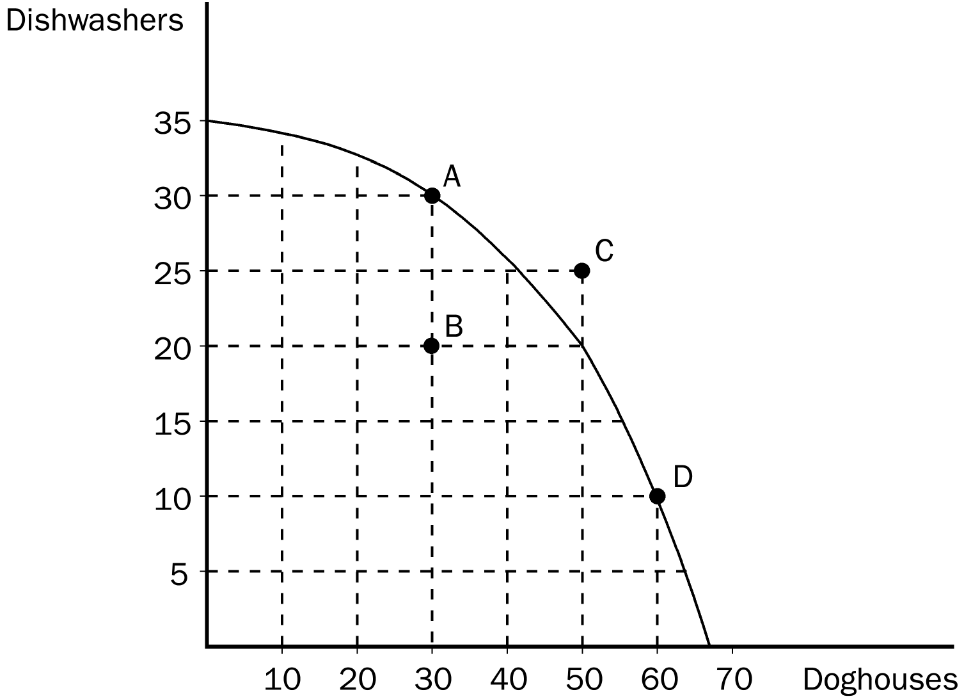
12. An efficient outcome in economics is one in which the economy is conserving the largest possible amount of resources, while still meeting the needs of society.
ANSWER: F TYPE: T SECTION: 1
13. An economy is being efficient if it is impossible to produce more of one good without producing less of another.
ANSWER: T TYPE: T SECTION: 1
14. In the graph shown, points A, B, and D represent feasible or attainable outcomes for society.
ANSWER: T TYPE: T SECTION: 1
15. In the graph shown, the opportunity cost to the economy of moving from point A to point B is 10 dishwashers.
ANSWER: T TYPE: T SECTION: 1
16. In the graph shown, the opportunity cost of more doghouses increases as more doghouses are produced.
ANSWER: T TYPE: T SECTION: 1
17. The tradeoff between the production of different goods can change because of technological improvement over time.
ANSWER: T TYPE: T SECTION: 1
18. Economic growth causes a production possibilities frontier to shift outward.
ANSWER: T TYPE: T SECTION: 1
19. If government regulations designed to protect U.S. wetlands removed very productive farmland from production, the production possibilities would shift inward.
ANSWER: T TYPE: T SECTION: 1
20. The field of economics is divided into two subfields: microeconomics and macroeconomics.
ANSWER: T TYPE: T SECTION: 1
21. Normative statements describe how the world is, while positive statements prescribe how the world should be.
ANSWER: F TYPE: T SECTION: 2
22. “Society would be better if the welfare system were abolished” is a normative statement, not a positive statement.
ANSWER: T TYPE: T SECTION: 2
23. When economists are trying to explain the world they are acting as scientists, and when they are trying to improve it, they are policymakers.
ANSWER: T TYPE: T SECTION: 2
24. The Council of Economic Advisors has as its duties both advising the President of the United States and formulating monetary policy.
ANSWER: F TYPE: T SECTION: 2
25. A survey of business, government, and academic economists revealed widespread disagreement on ten propositions about economic policy.
ANSWER: F TYPE: T SECTION: 3
26. Two variables which are negatively related will move in opposite directions.
ANSWER: T TYPE: T SECTION: 4
SHORT ANSWER
APPLICATION/SCENARIO
1. Using this outline, draw a circular-flow diagram representing the interactions between households and firms in a simple economy. Explain briefly the various parts of the diagram.

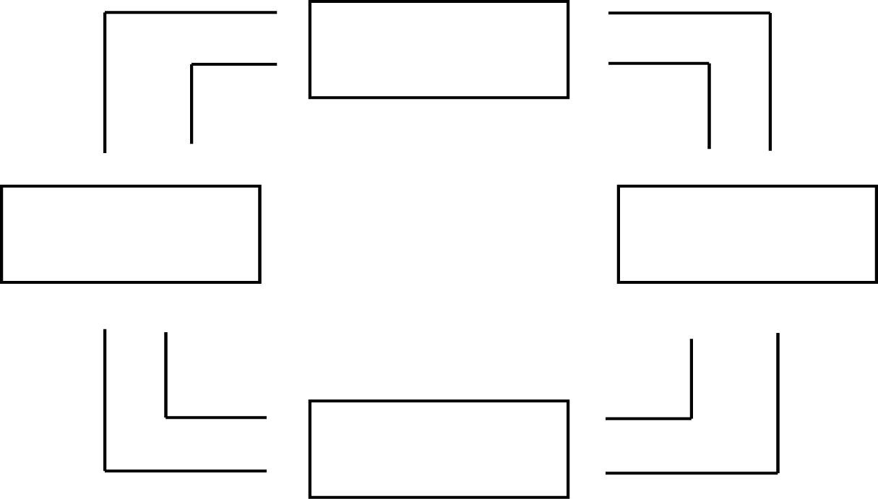

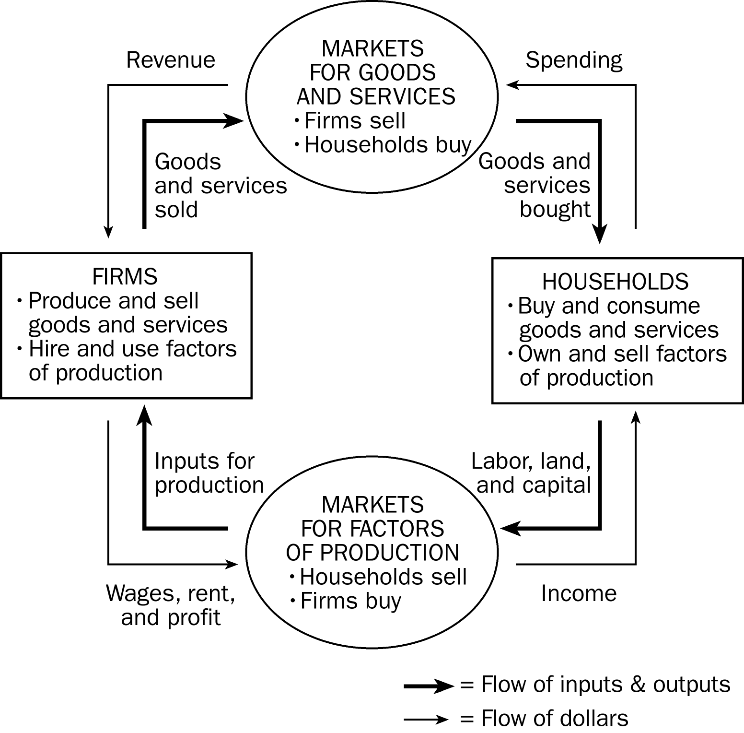
ANSWER:

This diagram should duplicate the essential characteristics of the diagram in the text, with an explanation of the meaning of each flow and each market. It is important that the student understands that the inner loop represents the flow of real goods and services and that the outer loop represents the corresponding flow of payments.
TYPE: S KEY1: G SECTION: 1 OBJECTIVE: 3 RANDOM: Y
2. Draw a production possibilities frontier showing increasing opportunity cost for hammers and horseshoes.
a. On a graph, identify the area of feasible outcomes and the area of infeasible outcomes.
b. On the graph, label a point that’s efficient as point “E” and a point that inefficient as point “I”.
c. On a graph, illustrate the effect of the discovery of a new vein of iron ore, a resource needed to make both horseshoes and hammers, on this economy.
d. On a graph for hammers and horseshoes, illustrate the effect a new computerized assembly line in the production of hammers would have.
ANSWER:

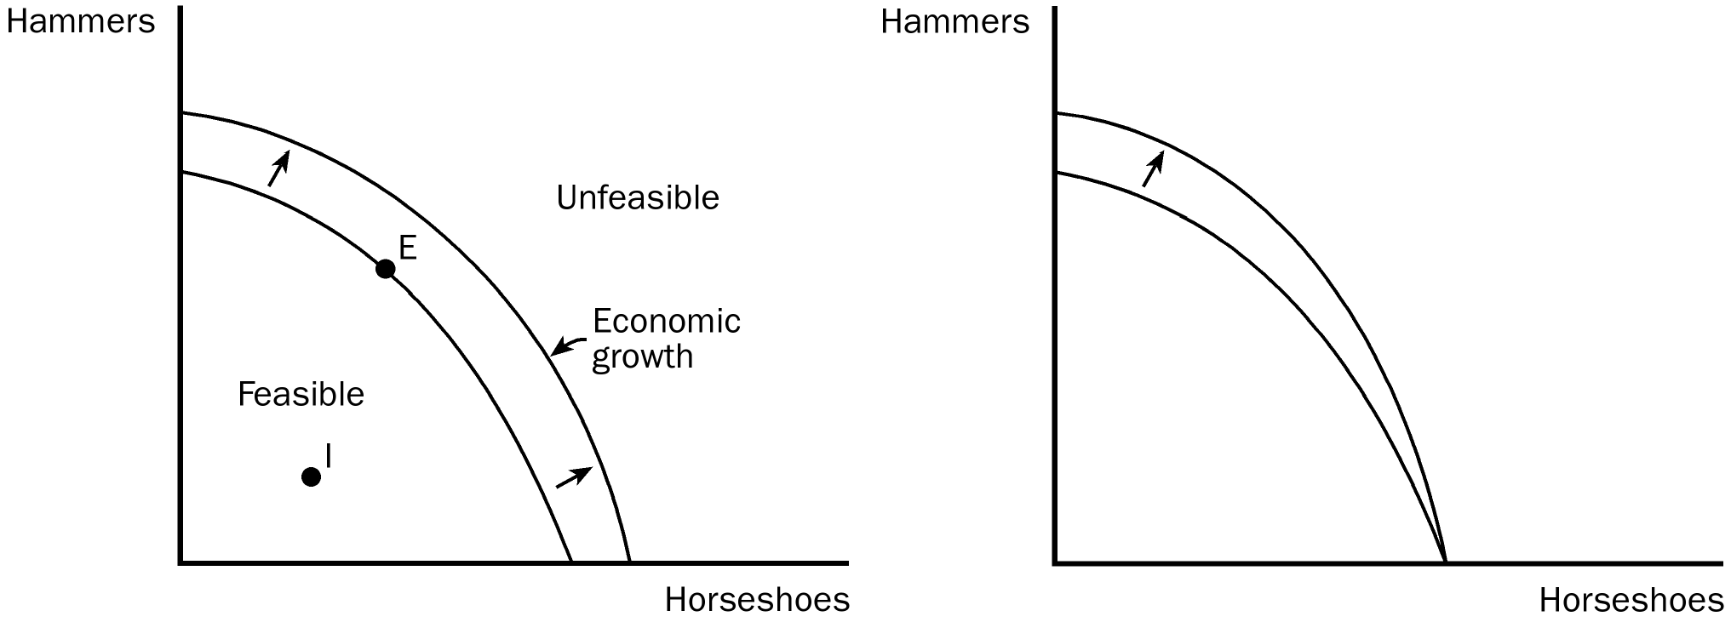

TYPE: S SECTION: 1
3. The prairie dog has always been considered a problem for American cattle ranchers. They dig holes that cattle and horses can step in and they eat grass necessary for cattle. Recently, ranchers have discovered that there is a demand for prairie dogs as pets. In some areas prairie dogs can sell for as high as $150. Cattlemen are now fencing off prairie dog towns on their land so these towns will not be disturbed by their cattle.
Draw a production possibilities frontier showing a rancher’s production option between cattle production and prairie dog production showing increasing opportunity cost and show what would happen in each of the following situations. (Use a separate graph for each situation.)
a. The outcome is efficient, with ranchers choosing to produce equal numbers of cattle and prairie dogs.
b. As a protest against the government introducing the gray wolf back into the wild in their state, ranchers decide not to use 25% of the available grassland for grazing.
c. The price of prairie dogs increases to $200 each, so ranchers decide to allot additional land for prairie dogs.
d. The government grants new leases to ranchers, giving them 10,000 new acres of grassland each for grazing.
e. A drought destroys most of the available grass for grazing of cattle, but not prairie dogs since they also eat plant roots.
ANSWER:

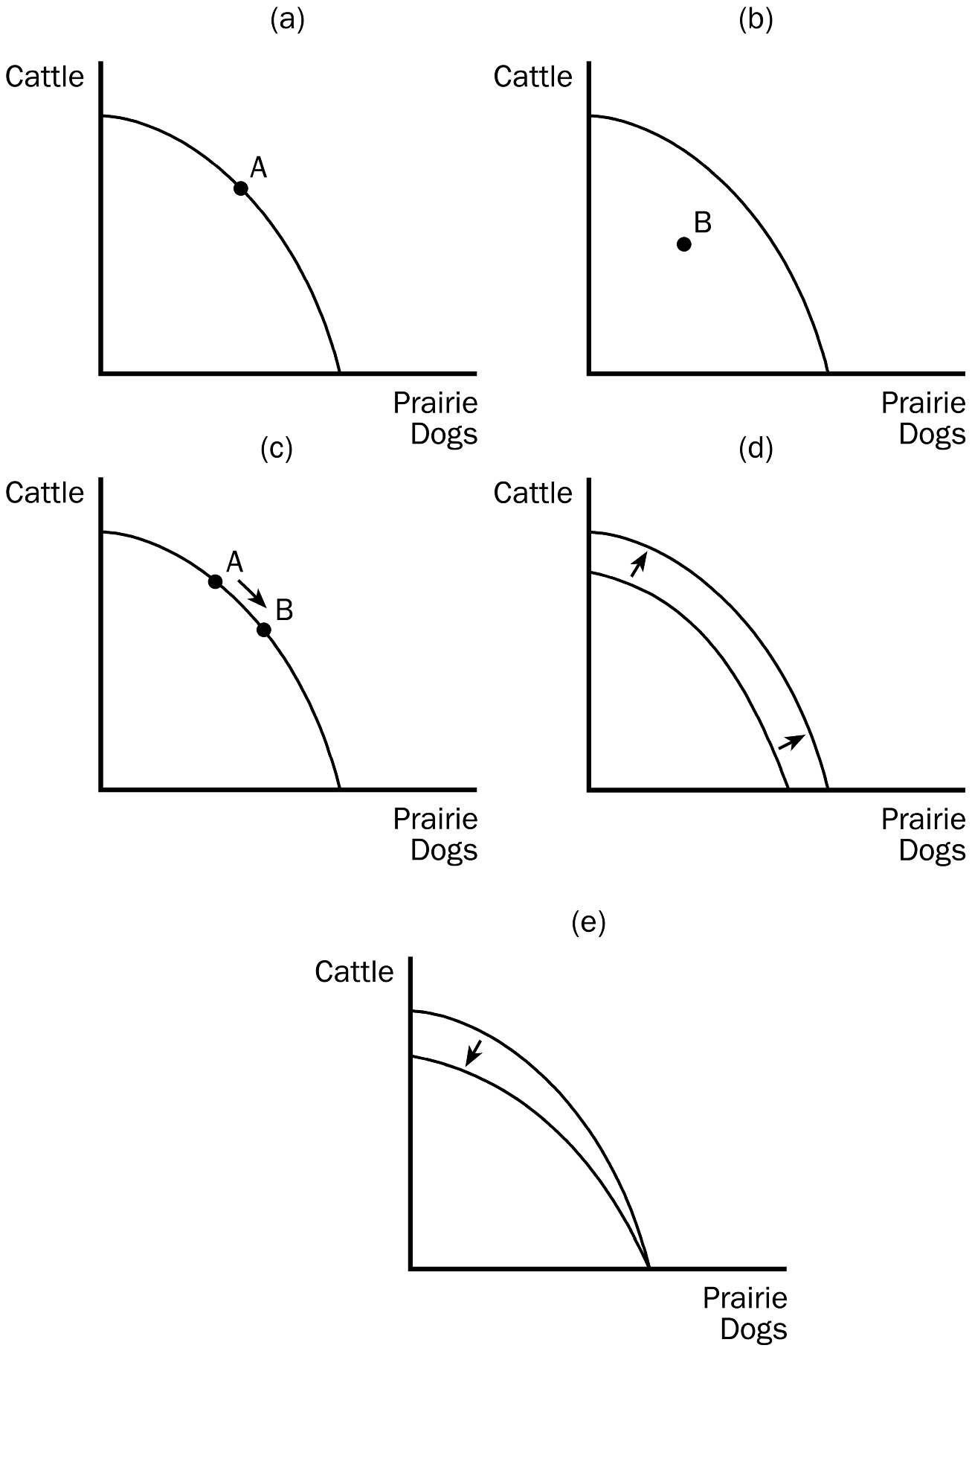

TYPE: S SECTION: 1
4. Identify each of the following topics as being part of microeconomics or macroeconomics:
a. the impact of a change in consumer income on the purchase of luxury automobiles
b. the effect of a change in the price of Coke on the purchase of Pepsi
c. the impact of a war in the Middle East on the rate of inflation in the United States
d. factors influencing the rate of economic growth
e. factors influencing the demand for tractors
f. the impact of tax policy on national saving
g. the effect of pollution taxes on the U.S. copper industry
h. the degree of competition in the cable television industry
i. the effect of a balanced-budget amendment on economic stability
j. the impact of deregulation on the savings and loan industry
ANSWER: a, b, e, g, h, and j are microeconomic topics. c, d, f, and i are macroeconomic topics.
TYPE: S SECTION: 1
5. Which of the following statements are positive, and which are normative?
a. The minimum wage creates unemployment among young and unskilled workers.
b. The minimum wage ought to be abolished.
c. If the price of a product in a market decreases, other things equal, quantity demanded will increase.
d. A little bit of inflation is worse for society than a little bit of unemployment.
e. There is a tradeoff between inflation and unemployment in the short run.
f. If consumer income increases, other things equal, the demand for automobiles will increase.
g. The U.S. income distribution is not equitable.
h. U.S. workers deserve more liberal unemployment benefits.
i. If interest rates increase, investment will decrease.
j. If welfare benefits were reduced, the country would be better off.
ANSWER: a, c, e, f, and i are positive statements. b, d, g, h, and j are normative statements.
TYPE: S SECTION: 2

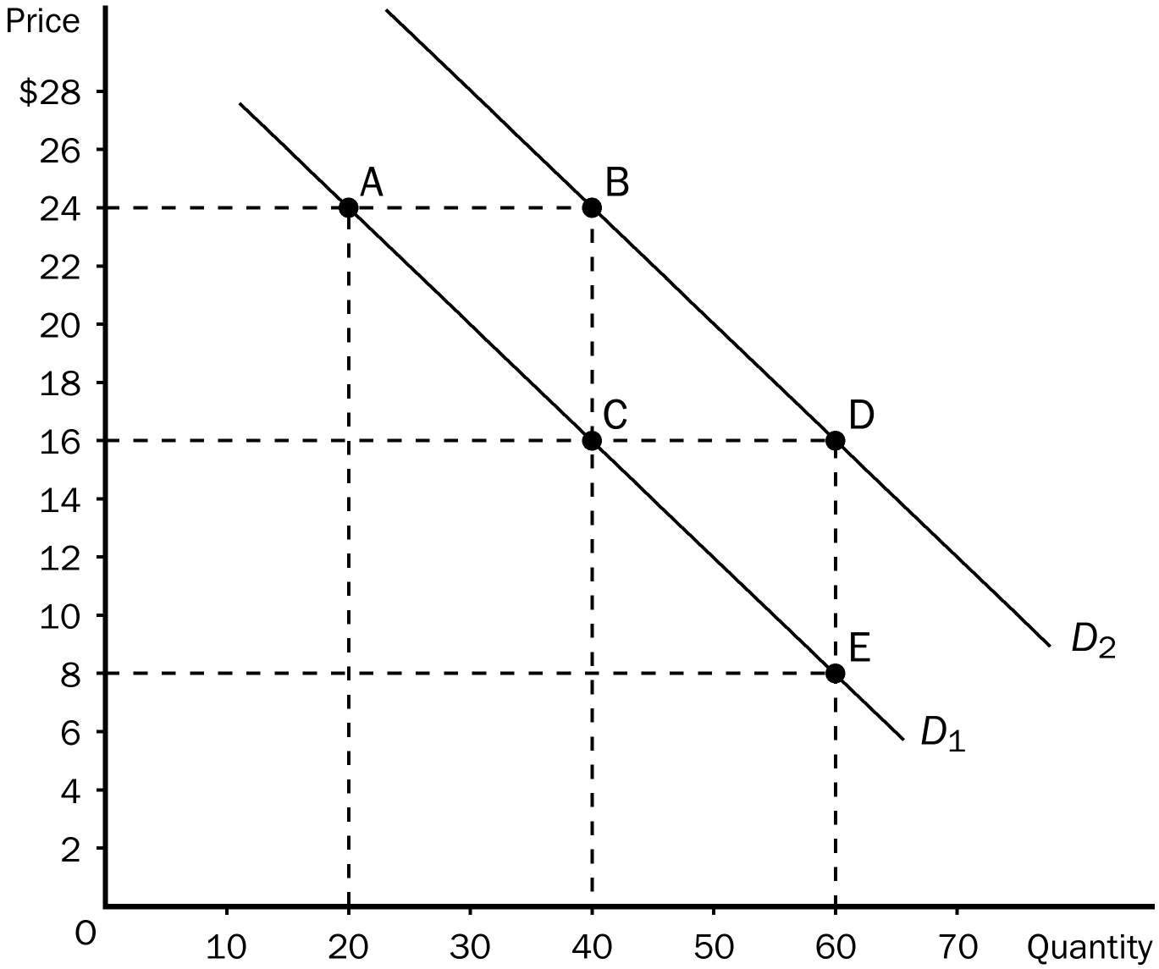
6. Use the following demand curve to answer the following questions.
a. How would point A be represented as an ordered pair?
b. What type of curve is this?
c. Does this curve show a positive or negative correlation between price and quantity?
d. Compute the slope of the D₁ between points A and C.
e. What is the slope of D₁ between points C and E? Why would you not have to calculate this answer?
f. What is it called if we move from D₁ to D₂?
g. How do you know that the slope of D₂ is the same as the slope of D₁?
ANSWER:
a. (20, 24)
b. a demand curve
c. a negative correlation between price and quantity
d. –8/20 or –2/5.
e. –2/5; because the slope of a straight line is constant.
f. an increase in demand.
g. The 2 lines are parallel.
TYPE: S SECTION: 2

